Introduction
The Town Forest Visioning Workshop and Survey are integral parts of the overall public engagement process for the Your Town Forest Recreation Plan, which also includes a series of steering committee and community meetings, as well as input from the Town government and other stakeholders and partnering organizations.
To ensure the greatest possible participation in the visioning process, the same visioning questions were asked at the public workshop and in the survey, although the survey asked a few demographic questions that were not asked at the workshop. Both public engagement methods were primarily focused on understanding the community vision related to the Town Forest(s), the management balance of the forest(s), the natural resources present on the site, and future activities in the Town Forest(s). The workshop results are presented in the photos of the public engagement “boards” completed by the community while the survey results are presented in tables of the combined survey responses. Key findings are reflective of both inputs, and areas of alignment and divergence are highlighted and analyzed.
As the workshop and survey are only one part of the overall community input into the plan, the Visioning Process Results should be considered descriptive of community sentiments rather than prescriptive. While these results should help point the way and direct the development of the plan, they must be measured alongside other community and Town inputs and should not be considered conclusive of the sentiments of everyone in the community.

Public Visioning Workshop
A Public Visioning Workshop for Your Town Forest was held at Location on Date. The meeting was a drop-in anytime, open house format with questions about an overall vision for the town forest; the balance of recreation, education, conservation/natural resources, and forest products; the natural resources present on the site; and future activities in the Town Forest. Attendees wrote responses on boards, completed dot exercises, and drew their ideas and knowledge on maps. Members of the local steering committee were available for one-on-one chats with attendees, and a general comment box was provided for open-ended feedback. Background/baseline information about the project, the community, and the forest, was also provided. XX people signed in and an estimated XX people were in attendance.

Public Visioning Survey
The Public Visioning Survey was launched at the public visioning workshop on DATE and remained open through DATE. Both online and hard copy surveys were made available (if applicable). The community was made aware of the survey through a variety of methods including flyers distributed around town, press releases and news articles, and email blasts and social media posts. In total, the survey received XX responses—XX online and XX hard copy. Survey results presented here represent combined responses to both the online and hard copy versions of the survey.

Visioning Process Results

Demographics (Survey Only)

Location of Residence
Some/Most/All of the respondents were from TOWN NAME, while Few/Some/Most/All were residents from neighboring towns, second home-owners, and visitors from afar.

Median Age
Survey results tended to skew towards an older demographic. Most survey respondents where in their XXs, while the median age of the Town overall is XX (see community profile data).

School Age Kids
Few/Some/Most/All survey respondents have school age children, suggesting we received a poor/fair/good/excellent sample of families in town.

Familiarity with our Forest
Few/Some/Most/All survey respondents had visited our town forest(s) before.

Of those who had not visited, XX was the most common reason for not visiting.

Write in responses included:

Forest Visitation
Of those who had visited our forest, the most visited rarely/a few times a year/at least once a month/at least once a week/everyday. There was also a strong number of respondents who visit rarely/a few times a year/at least once a month/at least once a week/everyday.

Survey Respondent Affiliations
The survey asked respondents if they have an affiliation with the Town (Conservation Commission, Town Forest Committee, etc.), interest group (trail club/group, rod and gun club, etc.), or partnering organization (land trust, library, school district, etc.). Many respondents did not have an affiliation..
Affiliations included:
- List

Overall Vision
Survey respondents and workshop participants were asked: “What word or phrase best describes your EXISTING experience with our town forest?” and “What word or phrase best describes your DESIRED FUTURE experience with our town forest?”

Survey Responses

Existing
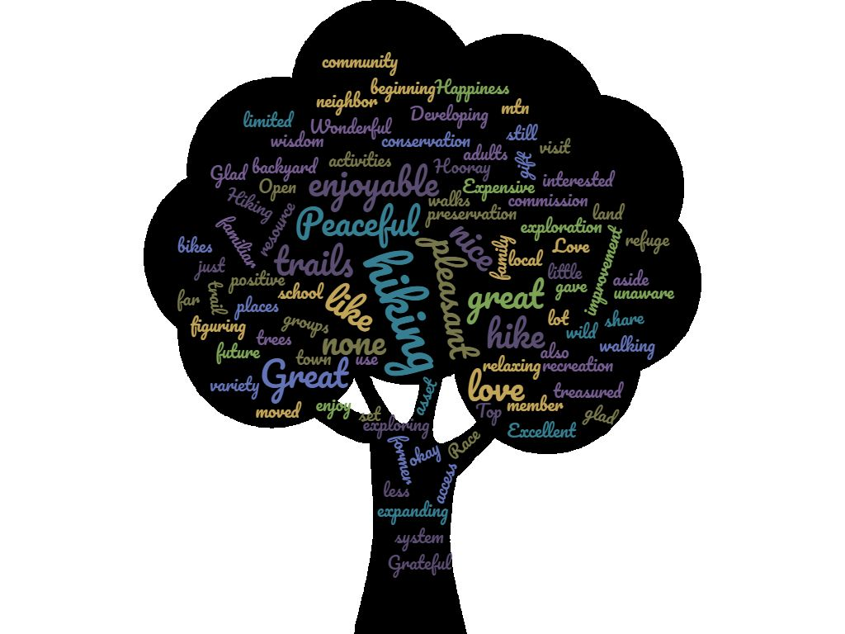
How to Create a Word Cloud:
Go to www.wordclouds.com. Copy all responses. On wordclouds.com, click “File” then “Paste/Type Text” and paste in the copied responses. Click “Apply.” Click on “Shape” and select the deciduous tree.
Click on “Mask” and remove the x so there is a check mark.
Click on “Colors. Under “Cloud Colors” click “Hex”.
Enter #FFFFFF for the background color.
Enter the following Hex codes for colors 1-8
#77774B, #7DA456, #C2A558, #745B90, #77774B, #367E92, #6473B7, #5B4D72
Click “Apply”
Click on “Colors” again and make the mask color black.
Click “File” and save as a jpg to paste into document.

Verbatim Responses:

- List

Desired Future
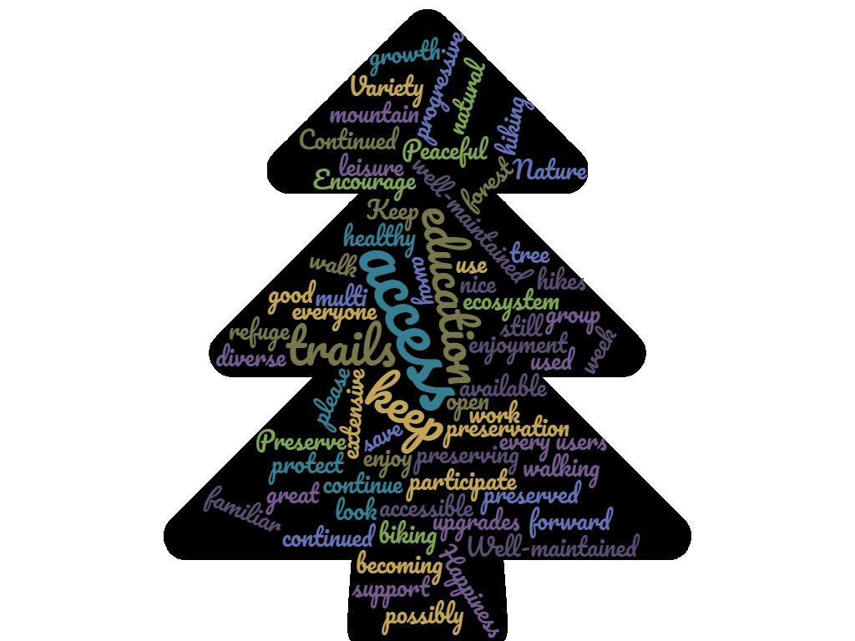
Repeat steps from creating existing conditions wordcloud. Use evergreen tree.

Verbatim Responses:

- List

Public Workshop
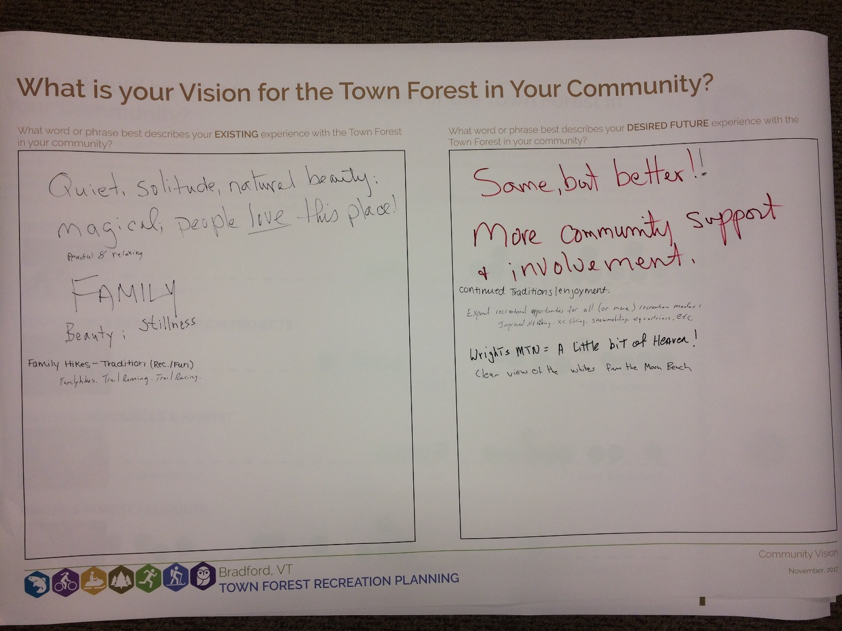
Paste image of vision board from workshop

Management Balance
Town Forests can be managed to provide a wide range of activities and community values. Four common use areas include Recreation, Education & Land Use Demonstration Projects, Natural Resources & Habitat, and Timber & Forest Products. While most publicly accessible forests provide some measure of all four types of uses, they tend to “lean” in one management direction or another.
To understand this balance, survey and workshop participants were asked “Where do you think the management focus should fall for the Town Forest in your community? Should it lean towards Recreation, Education, Timber & Forest Products, or Natural Resources & Habitat?”

Survey Responses
Qualitatively describe how the survey respondents answered this question. Insert chart if possible.

Public Workshop
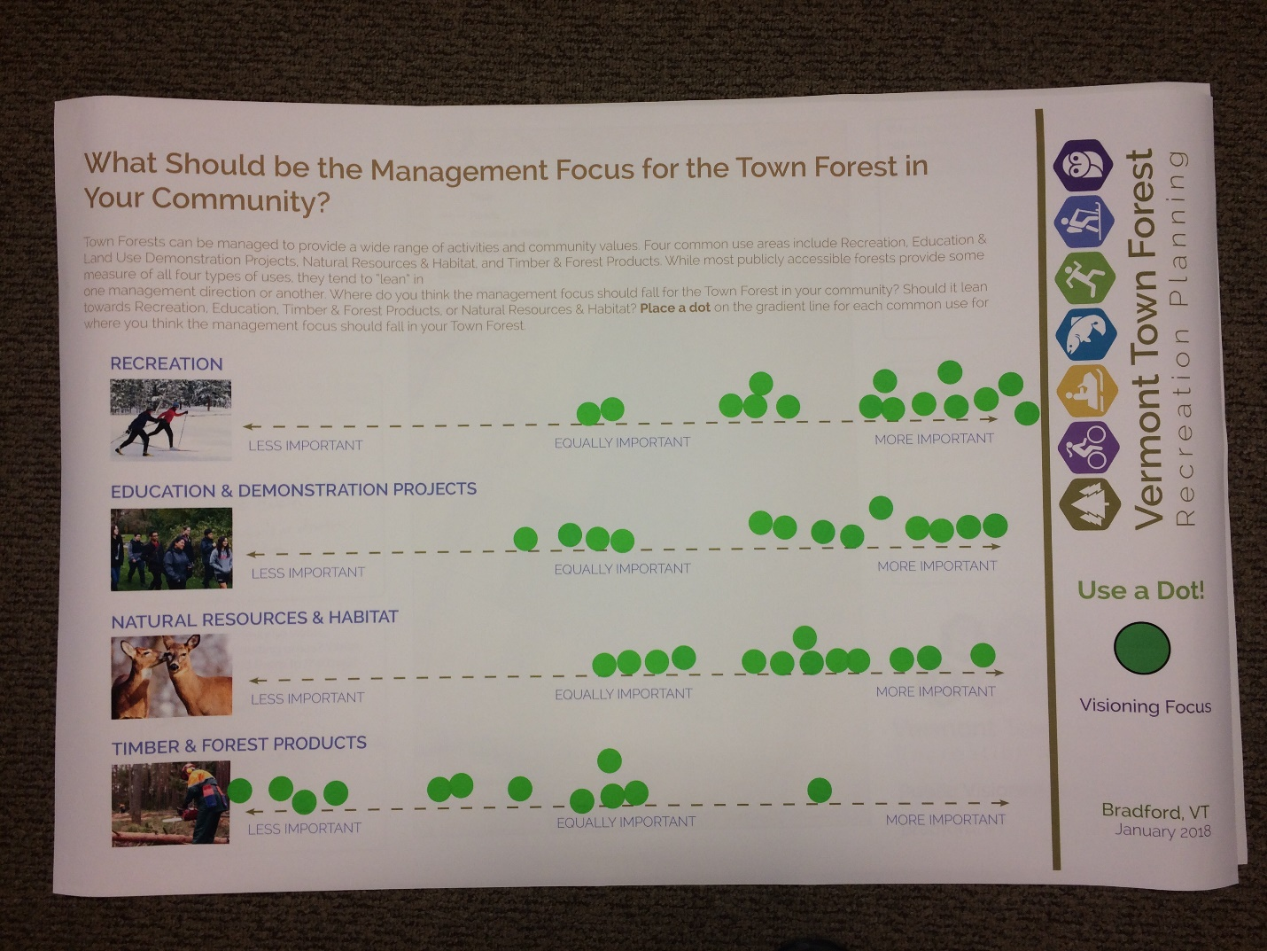
Paste image of balance board from workshop

Analysis
Insert 3-5 sentences of analysis – which uses did the community think were more important? Which did they think were less important? What were differences between survey and workshop respondents?

Natural Resources

Present Natural Resources
Survey respondents identified the following ‘natural resources of note’ in the Town Forest:
- Deer Wintering Areas
- Vernal Pools
- Large Ledges or Cliffs
- Groundwater Seepage Areas
- Forested Swamps
Open-ended responses include:
- List

Wildlife
Survey respondents identified the following wildlife using the forest:
- List

Natural Resource Protection Concerns
When asked “Are there any human activities (existing or planned) that may conflict with these resources?” survey respondents answered:
- List

Public Workshop
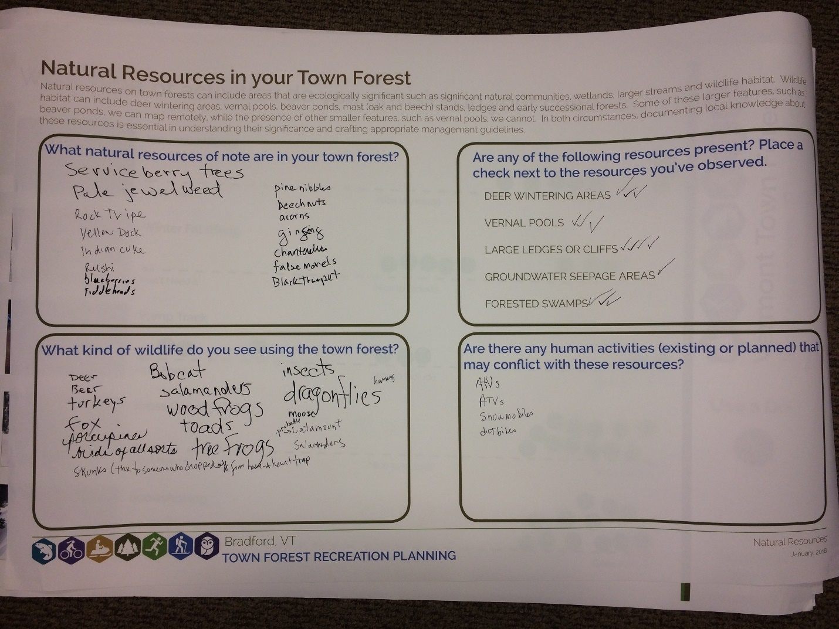
Paste image of natural resources board from workshop

Recreation Activities
Survey respondents and workshop participants were asked about the recreation activities they envisioned in their town forest by indicating their feelings about a number of activities on a spectrum from “Don’t need it” to “Nice to include” to “Gotta have it”.

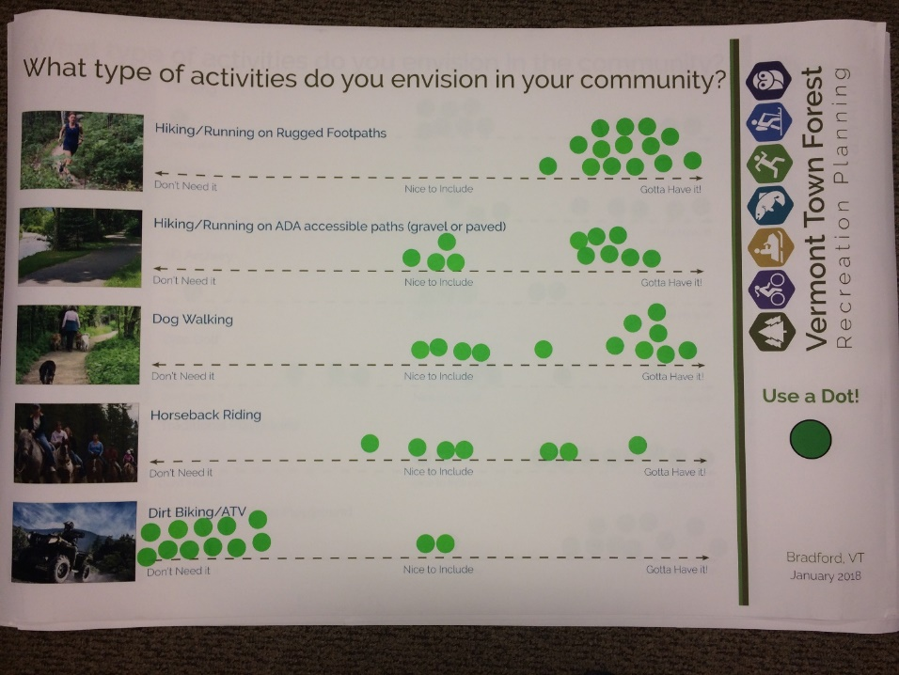
Paste image of recreational activities board #1 from workshop

Insert two to four sentence analysis. Which activities were respondents most interested in? Which were they least interested in? Neutral towards? How did survey respondents and workshop participants differ?
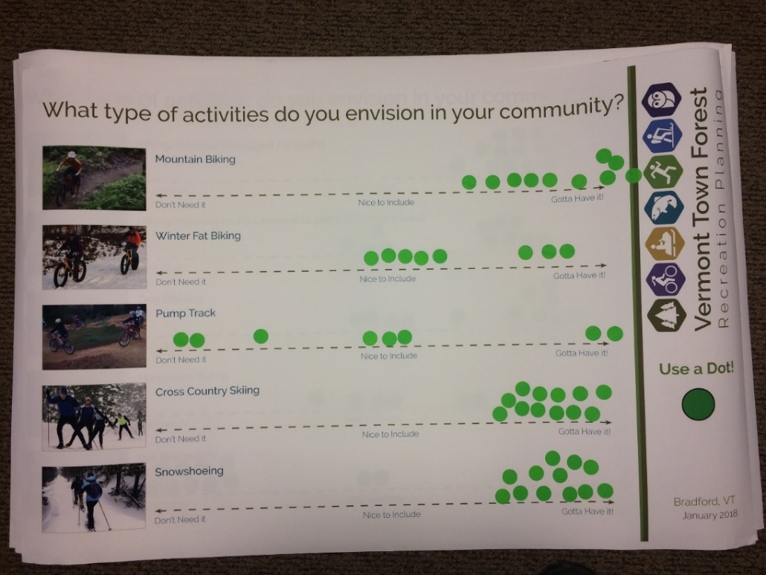
Paste image of recreational activities board #2 from workshop

Insert two to four sentence analysis. Which activities were respondents most interested in? Which were they least interested in? Neutral towards? How did survey respondents and workshop participants differ?
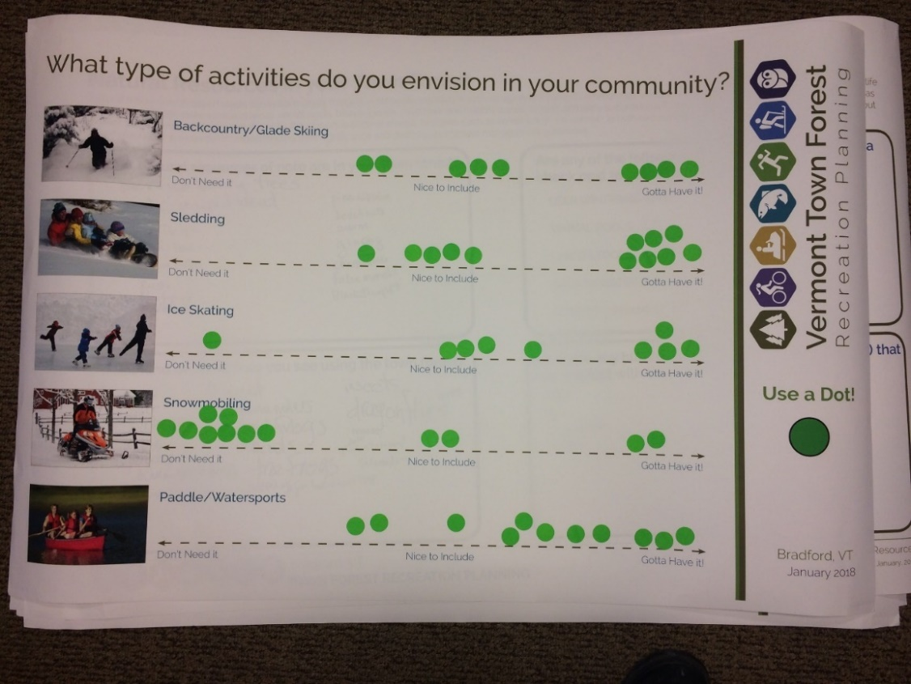
Paste image of recreational activities board #3 from workshop

Insert two to four sentence analysis. Which activities were respondents most interested in? Which were they least interested in? Neutral towards? How did survey respondents and workshop participants differ?
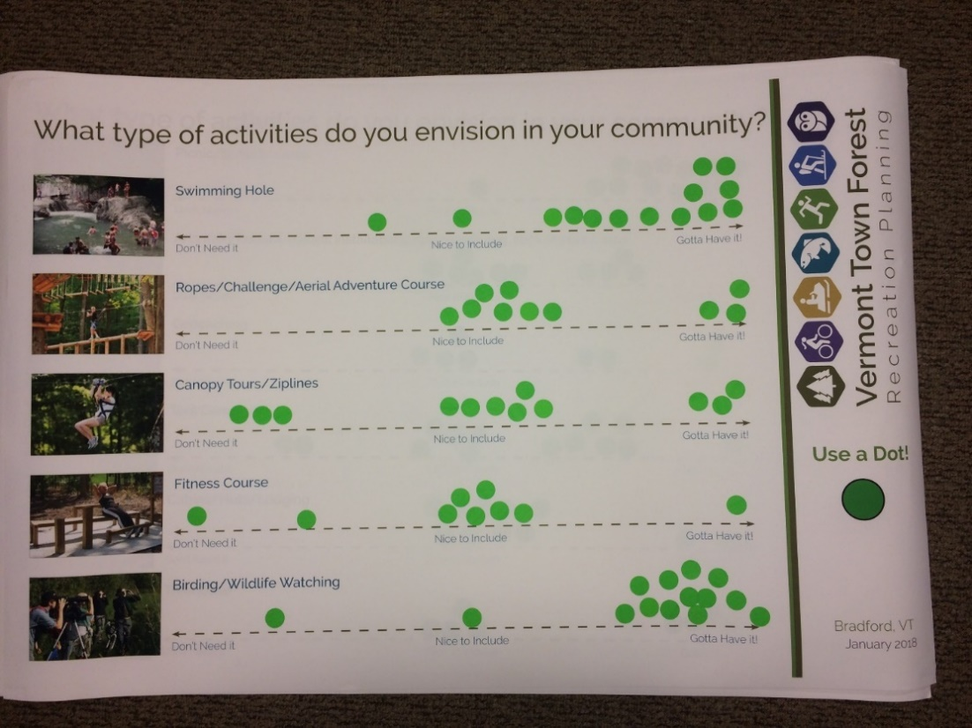
Paste image of recreational activities board #4 from workshop

Insert two to four sentence analysis. Which activities were respondents most interested in? Which were they least interested in? Neutral towards? How did survey respondents and workshop participants differ?
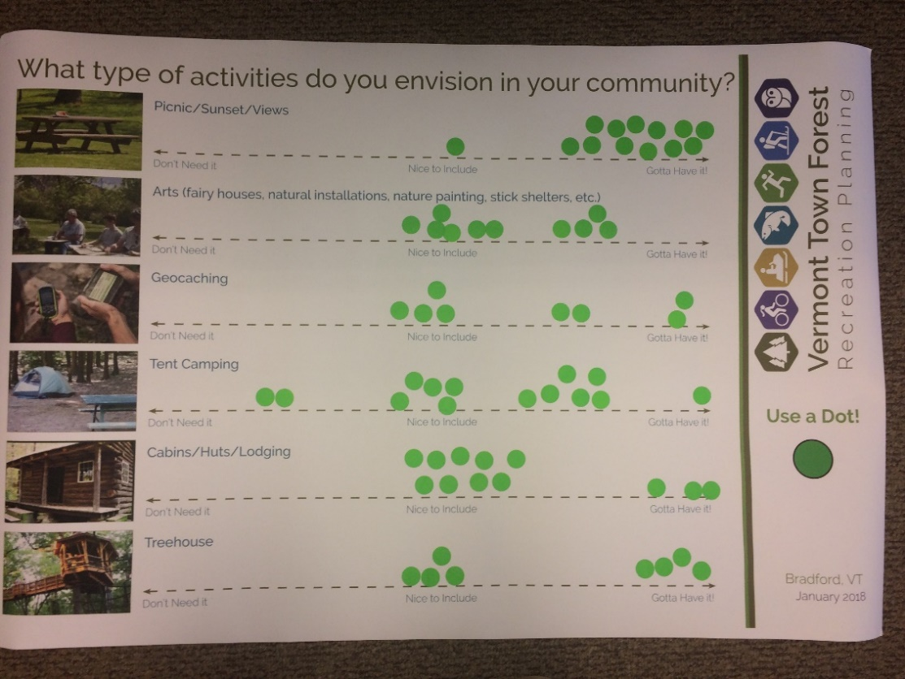
Paste image of recreational activities board #5 from workshop

Insert two to four sentence analysis. Which activities were respondents most interested in? Which were they least interested in? Neutral towards? How did survey respondents and workshop participants differ?
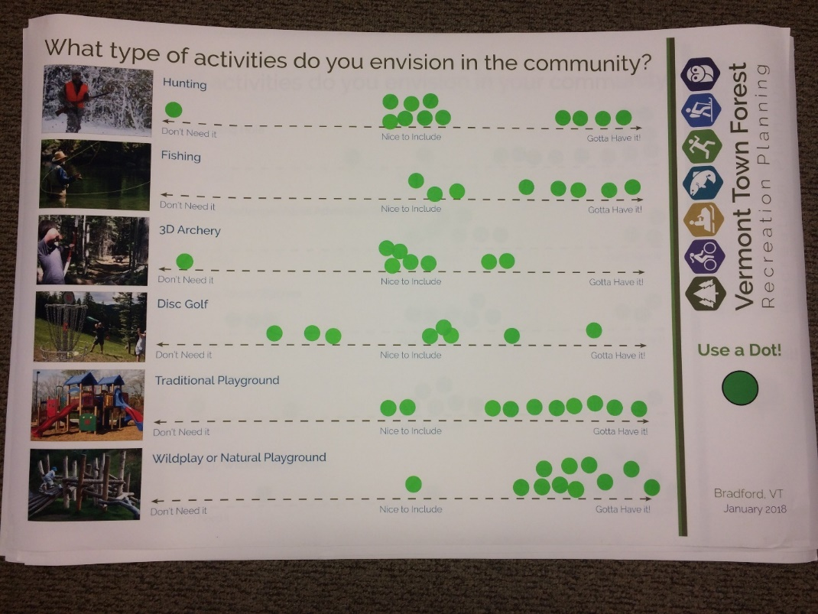
Paste image of recreational activities board #6 from workshop

Insert two to four sentence analysis. Which activities were respondents most interested in? Which were they least interested in? Neutral towards? How did survey respondents and workshop participants differ?
Open ended responses to the question “Are there other activities or facilities you would like to see added to our town forest?” included:
- List
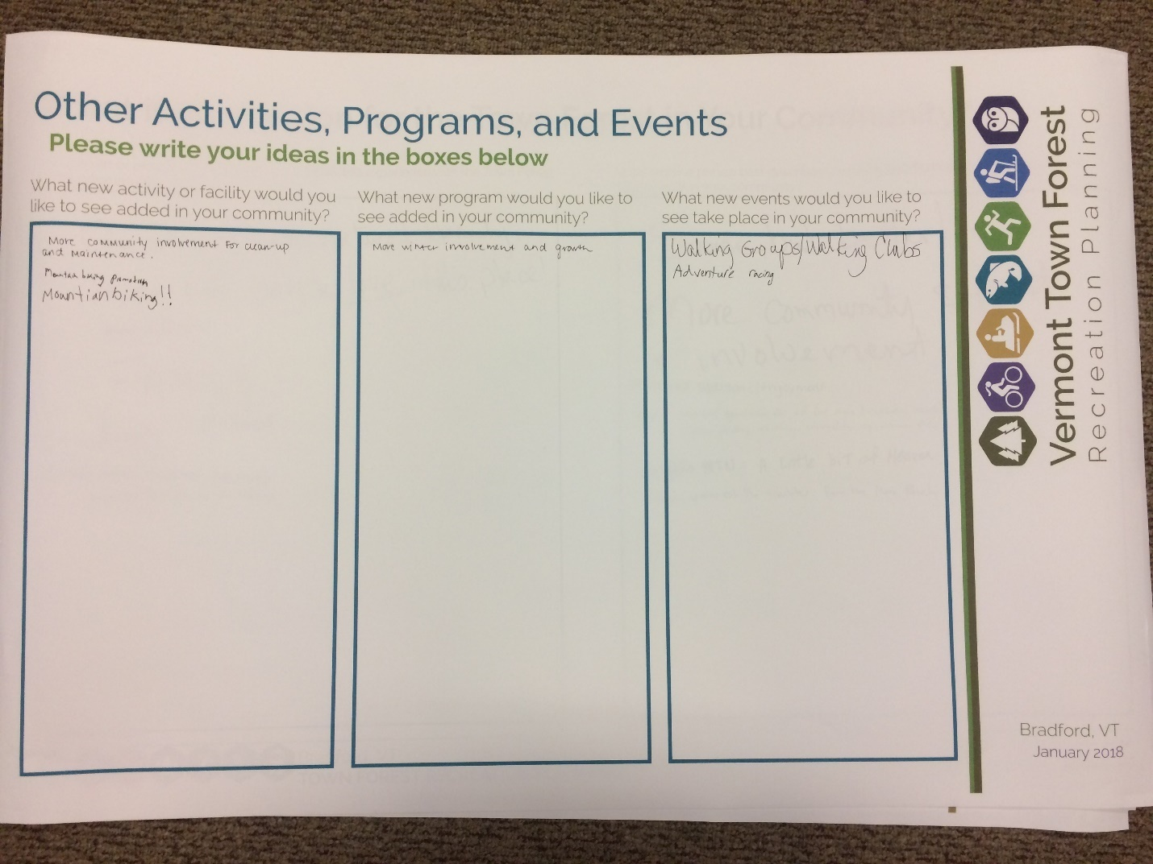
Paste image of write in activities, programs, and events board from workshop

Recreation Programming
Survey respondents and workshop participants were asked about the recreation programs they envisioned in their town forest by indicating their feelings about a number of programs on a spectrum from “Don’t need it” to “Nice to include” to “Gotta have it”.

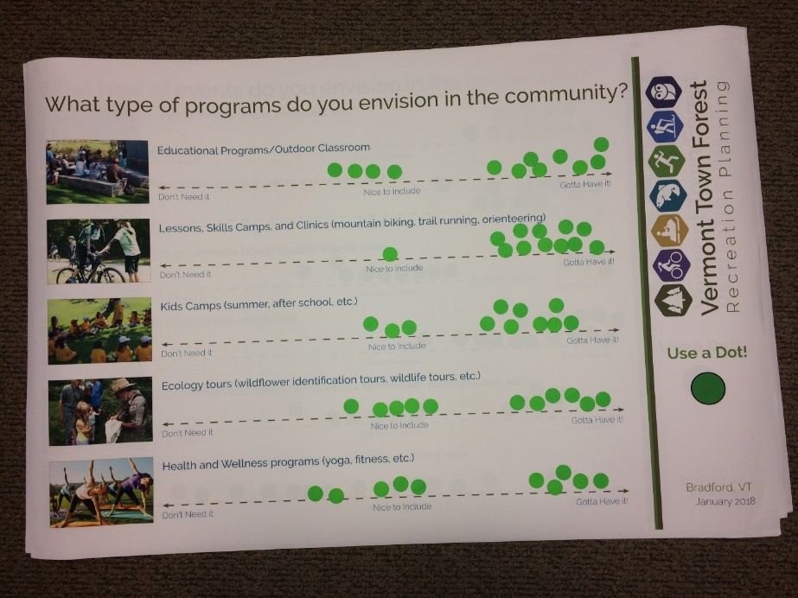
Paste image of recreational programs board from workshop

Insert two to four sentence analysis. Which programs were respondents most interested in? Which were they least interested in? Neutral towards? How did survey respondents and workshop participants differ?
Open ended responses to the question “Are there other programs you would like to see added in our Town Forest?” included:
- List
Paste image of write in activities, programs, and events board from workshop

Events in the Town Forest
Survey respondents and workshop participants were asked about the events they envisioned in their town forest by indicating their feelings about a number of events on a spectrum from “Don’t need it” to “Nice to include” to “Gotta have it”.

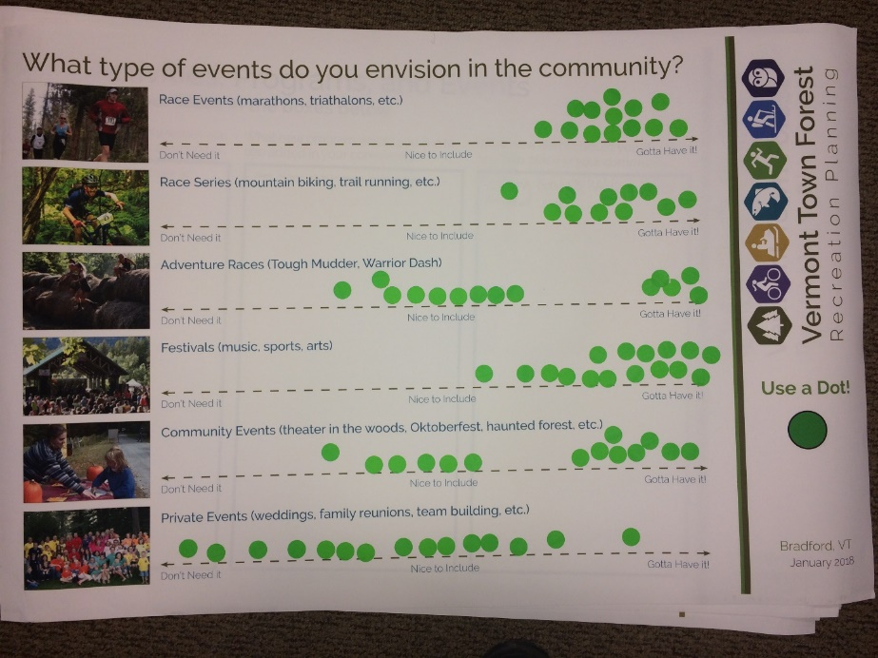
Paste image of recreational events board from workshop

Insert two to four sentence analysis. Which events were respondents most interested in? Which were they least interested in? Neutral towards? How did survey respondents and workshop participants differ?
Open ended responses to the question “Are there other events you would like to see added in our Town Forest?” included:
- List
Paste image of write in activities, programs, and events board from workshop

Floor Map
Workshop participants were asked to draw in their ideas on a large format map at the workshop.
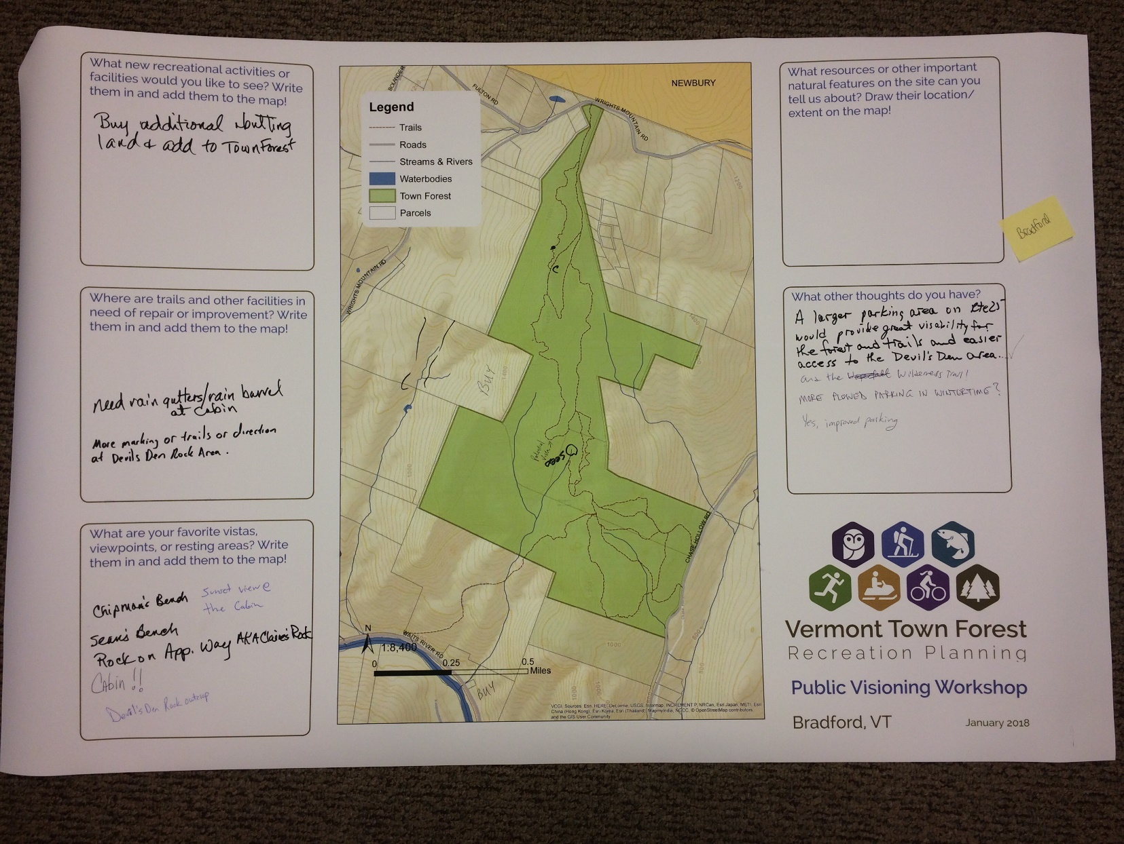
Paste image of write of floor map and associated question sheet

Final Thoughts
Open ended responses to the question “Are there any other thoughts, concerns, or comments you'd like share about our town forest or outdoor recreation in our community?” included:
- List

Comment Cards
List if collected

