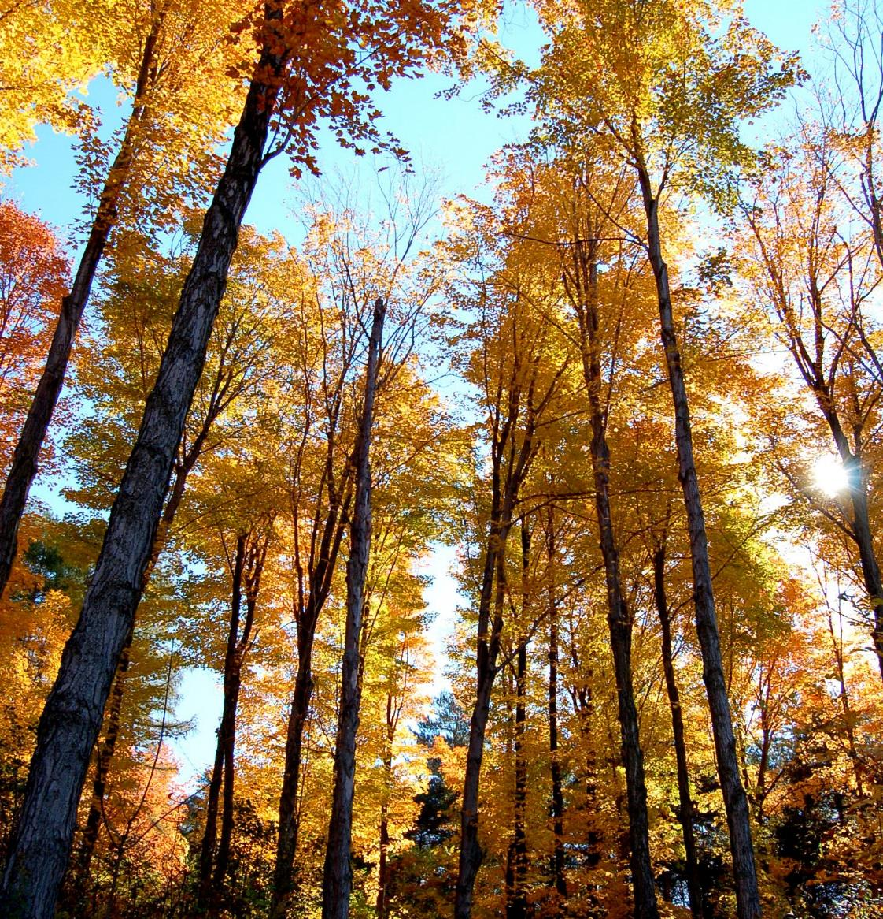
Town of XX, Vermont

TOWN FOREST RECREATION PLAN

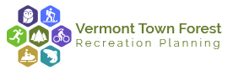

Contents
Chapter 1: Introduction 4
Acknowledgements 4
Project Team 4
About the Vermont Town Forest Recreation Planning Community Assistance Program 5
Project Purpose and Scope 5
Project Process 6
How to Use This Plan 6
Community Benefits of Recreation in Town Forests 7
Conservation and Habitat Protection 7
Close to Home Recreational Opportunities 8
Economic Development 8
Health Benefits 9
Chapter 2: Existing Conditions 10
Community Profile 10
Summary 10
Town Forest Profile 12
Forest Overview 12
Land Ownership and Conservation Background 12
Chapter 3: Public Engagement Summary and Needs Assessment 17
Public Engagement 17
Steering Committee Process 17
Visioning Workshop 17
Community Survey 18
Strategies Workshop 19
Plan Presentation Workshop 19
Needs Assessment 20
Chapter 3: Town Forest Vision Framework 21
Visioning 21
Management Balance 23
Key Attributes 25
Chapter 5: Action Plan 26
Introduction 26
High Priority Projects 26
Project Name 27
Project Name 28
Trail Markers and Signage 28
Educational Programs and Partnerships 29
29
Action Plan Graphic 29
Action Plan Table 31
Chapter 6: Implementation 37
Town Forest Recreation Planning Toolkit 37
Existing Conditions Pod 38
Public Engagement Pod 39
Natural Resources Pod 40
Plan Development Pod 42
Implementation Pod 43
Town Forest Story Pod 44
Grants and Funding Sources 45
Federal and State Grants and Programs 45
State Grants and Programs 47
State Organizations 49
National Organizations 50
How Template Town Intends on Using this Plan 51

Chapter 1: Introduction

Acknowledgements
All community plans are the result of a collective effort. In the development of this Town Forest Recreation Plan many individuals provided considerable input and expertise to the outcome. The project team would like to thank them for their tremendous assistance.

Project Team
Our Partners
The Vermont Urban & Community Forestry Program is a joint initiative of Vermont Department of Forests, Parks and Recreation (FRP) and UVM Extension. Working group members include FPR’s Recreation Program, Agency of Commerce and Community Development, and Extension’s Tourism and Marketing Program. Partners include over 40 organizations and stakeholders who have helped shape the process and deliverables.

Steering Committee
- List Steering Committee Members

Interagency Working Group
- VT Urban and Community Forestry Program—Project Lead
- VT Agency of Natural Resources—Department of Forests, Parks and Recreation
- VT Agency of Commerce and Community Development

Toolkit Development Consultant Team
- SE Group—Project Lead
- Arrowwood Environmental—Natural Resources Sub-Consultant

About the Vermont Town Forest Recreation Planning Community Assistance Program
Vermont has a long and proud tradition of town-owned and managed forests. Over 168 municipalities own over 67,000 acres of forestland, all open for public benefit. The values of these town forests are diverse, including watershed protection, wildlife habitat, forest products, outdoor classrooms, and neighborhood gathering places. Outdoor forest-based recreation is both a great opportunity and a growing challenge. Recognition of the economic and community benefits of forest-based recreation is on the rise. Concurrently, increased pressure from multiple recreation groups accentuate the need for planning assistance to balance the growing recreation interests and the health of the forest. In response, the Vermont Urban & Community Forestry Program and its partners received a grant from the US Forest Service to provide recreation planning assistance to ten diverse Vermont communities, and a recreation planning toolkit accessible to towns across the state. Our town has utilized this toolkit, developed by the consulting firms SE Group and Arrowwood Environmental, to produce this plan.

Project Purpose and Scope
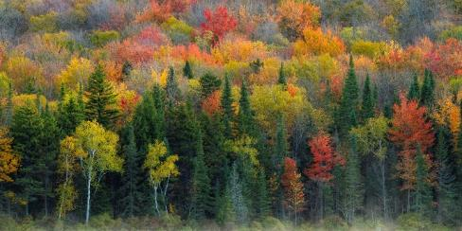
At the broadest level, the Vermont Town Forest Recreation Planning Community Assistance Program is intended to empower communities to move forward with confidence on recreation projects in their Town Forest. This process has provided robust community involvement and comprehensive consideration of potential projects, so the community can move forward with confidence knowing that it is addressing the needs and preferences of its residents and visitors, is protecting the forest resources in its charge, and is effectively managing the forest for the resources and activities it values.
The project encompasses three key areas:
- Developing a compelling and inspiring vision to help guide the future management of the town forest
- Developing discrete, clear and action-oriented strategies for improvement of recreation and stewardship that achieves the vision
- Fostering implementation with support for local plan adoption, guidance for implementation, and the project toolkit

Project Process
Over the past year, our community has engaged in a robust planning process to develop an action-based town forest stewardship and recreation plan. This process has followed the Vermont Town Forest Recreation Planning Toolkit to plan for sustainable, forest-based recreation in our forest. The innovative planning model included a public visioning workshop, needs assessment, facilitated walks in the forest, a community survey, a public strategies workshop, and a steering committee leading the way. This process has resulted in a plan that provides actionable strategies to assist the community in taking the next steps.

How to Use This Plan
First and foremost, this plan is intended to document the community’s desires for the town forest. Through robust public engagement, the planning process identified and solidified the community’s comprehensive vision, which encompasses all the primary uses of town forests: conservation, recreation, education, and timbering and forest products. When decisions are being made about the town forest, the vision outlined in this document should be referred to and should inform how the community might weigh in on the future direction of the forest.
In addition to the establishing a shared vision for the forest, this planning process has also identified a series of concrete actions the town and its partners could take to implement the community’s vision for the forest in terms of recreation. Strategies for improvement of recreation could be physical enhancements—such as new trails, parking lots, or facilities—but strategies might also be non-physical improvements like enhanced maps and signage or policy-oriented strategies like creating a process for proposing and reviewing new trails or projects in the forest. Potential strategies were chosen and prioritized by the steering committee and the public during the Draft Strategies Workshop. All strategies identified by the steering committee are found within the action plan table, and the committee listed the highest priority strategies as well.
For each strategy, the action plans identify:

- Project description
- Action responsibility
- Timing (immediate, short, medium, long-term)
- Partners involved
- Action or planning dependencies
- Available toolkits & support resources
- Funding & grant opportunities
- Magnitude of costs ($-$$-$$$-$$$$)

Some of the strategies can be implemented directly by the town, its volunteers, and partners without additional funding or resources—others may require additional planning and design or require grants to complete. If grants or additional planning and design steps are needed, likely funding sources and implementation partners are identified in the action plan.
The Vermont Town Forest Recreation Planning Toolkit—a companion to this plan—offers guidelines, designs, case studies, best practices, and standards for the town to pursue towards realizing its vision. Whether the next step involves recruiting volunteers, writing a grant application, or building a trail, the Toolkit can help the town and its partners move forward.
The Vermont Town Forest Recreation Planning Toolkit is available on Urban and Community Forestry’s website at: https://vtcommunityforestry.org/

Community Benefits of Recreation in Town Forests
Recreation in town forests provides many benefits for local residents, economies, and the natural communities of Vermont.

Conservation and Habitat Protection
A town forest, as a protected natural area, has intrinsic conservation value. They act as habitat for local species and help conserve the area’s natural resources. Town forests can connect existing forest blocks, providing a larger, safe habitat for species. Linked habitat blocks also allow species to travel and adapt to changing conditions. The forests also protect and buffer local streams, improving water quality and habitat for aquatic species. In absorbing and filtering water, the forests improve flood resiliency and water quality across the watershed. Forests also help protect soils and biodiversity and provide a buffer against pests and disease. As a municipally owned parcel, the forest can leverage additional funds for conservation through taxes and community development grants.
A town forest also provides humans with benefits from conservation by linking people to nature and allowing them to experience a wide range of natural environments. It is becoming clearer that contact with nature is an important element of a healthy life style. Providing convenient, local access to forests and natural areas can make it easier to connect with and experience nature, which is particularly important for the youth in our communities. According to the Institute for Social Research, the average American boy or girl spends just four to seven minutes in unstructured outdoor play each day, and more than six hours each day in front of an electronic screen (National Wildlife Federation, 2016). This is startling data that has been causing a ripple effect across the country. Nearly every industry that works with young people across the nation has established initiatives to help change this statistic. From school districts and environmental education organizations to federal land managers, conservationists and the outdoor retail industry, new funding streams for outreach and programs have developed.
There are several negative long-term effects of kids’ “nature deficit disorder,” as coined by Richard Louv, but the two greatest impacts are general health and well-being of America’s youth and the ability and desire for future generations to steward and value our public natural and wild areas, including our town forests. Although this national phenomenon is less of an issue in rural places like Vermont, convenient access to forests could help get even more young people outdoors more often.

Close to Home Recreational Opportunities
Town forests provide trails for both residents and visitors to enjoy. Town forest trails allow walkers, bikers, runners, skiers, and snowshoers to combine exercise and a natural experience in a convenient location without having to travel far from their home. Studies have shown that close and convenient access to recreation and the outdoors can significantly increase an individual’s physical activity levels (Schipperijn et al, 2017). Town forests may also connect surrounding trail systems, enhancing the community’s overall trail network. Town forest recreational opportunities can also integrate recreation with outdoor education through interpretive signage and nature walks, promoting other community values of health and nature education.

Economic Development
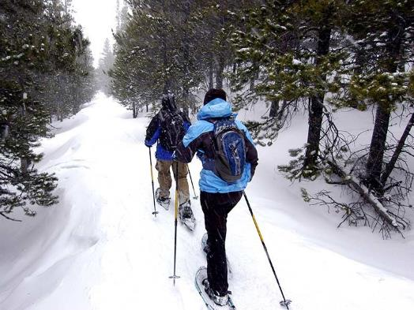
In Vermont, outdoor and forest-based recreation and the associated tourism are major drivers of the economy. Outdoor and forest-based recreation brings people into our communities. In the Mad River Valley, 78% of visitors have reported that trails and access to the outdoors was important in their decision to visit (MRV Moves, 2017). Trail users, both residents and visitors, will visit local restaurants and shops, bringing in tax revenue and creating jobs as well. Across our state, just four trail systems—the Catamount Trail, the Long Trail, the VAST system, and Kingdom Trails—have been found to generate over $30.8 million annual economic activity, over $2 million in annual tax revenues, and have supported over 365 jobs annually (VT Trails and Greenways, 2017). A single trail system in the Green Mountain National Forest—the Blueberry Lake Trails—has been found to generate $1.8 million in annual sales, $320,000 in annual tax revenues, and has supported 22 jobs annually (MRV Moves, 2017).
Many people when moving to Vermont will choose a location based on its natural features and recreational opportunities. Nationwide, the National Association of Realtors found that 80% of Americans consider having trails and places to take a walk one of their top priorities when deciding where they would like to live. This ranked higher than even “high quality public schools” in their Community Preference Survey, which was selected by 74% of survey respondents (National Realtors Association, 2015). Access to the outdoors is increasingly being seen as a cornerstone of quality of life, particularly in rural communities, and having this access allows communities to attract and retain their workforce, which in turn helps attract and retain businesses. Therefore, an accessible town forest can be a key factor for strengthening the economic vitality of Vermont towns.

Health Benefits
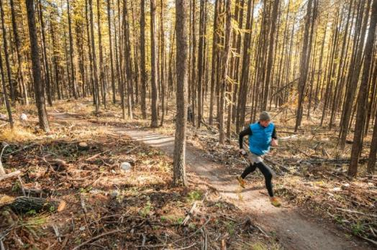
Almost all hospitals and health providers encourage patients to include some form of physical activities in their daily lives to increase many aspects of their health. By providing convenient access to the outdoors, a town forest encourages community members to walk, bike, ski, snowshoe, or run in the forest regularly.
Obesity is one of the most significant health threats today. More than two-thirds (68.8 percent) of American adults are considered to be overweight or obese. More than one-third (35.7 percent) of American adults are considered to be obese (U.S. Department of Health and Human Services. 2016). Vermont has slightly lower rates of overweight and obese Adults at 57.7% overweight and 23.2% obese, but the issue is of critical importance in our state as well (CDC, 2012). Active lifestyles and physical activity help to combat obesity. Obesity exacerbates many other types of illnesses and reducing the levels of obesity leads to overall better health.
Studies have shown that trails and outdoor recreation contribute to healthy communities and lower healthcare costs for individuals and local governments. A 2004 cost-benefit analysis of using trails in Lincoln, Nebraska to reduce health care costs associated with inactivity found that for every $1 invested in trails for physical activity, $2.94 of public health benefits are produced (Wang et al, 2004).
Spending time in the forest’s peaceful, natural setting is also proven to be beneficial to community members’ mental health. In addition, the forest’s trees improve the air quality of the surrounding area as well.

Chapter 2: Existing Conditions

Community Profile
The community profile presents relevant demographic, economic, and recreational information to planning for the town forest.

Summary
Summarize the information presented in the community profile
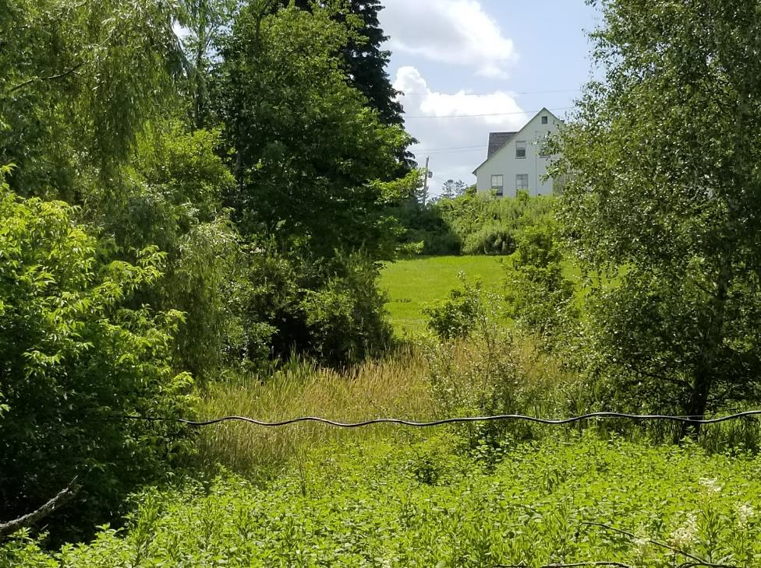
Photo of Town
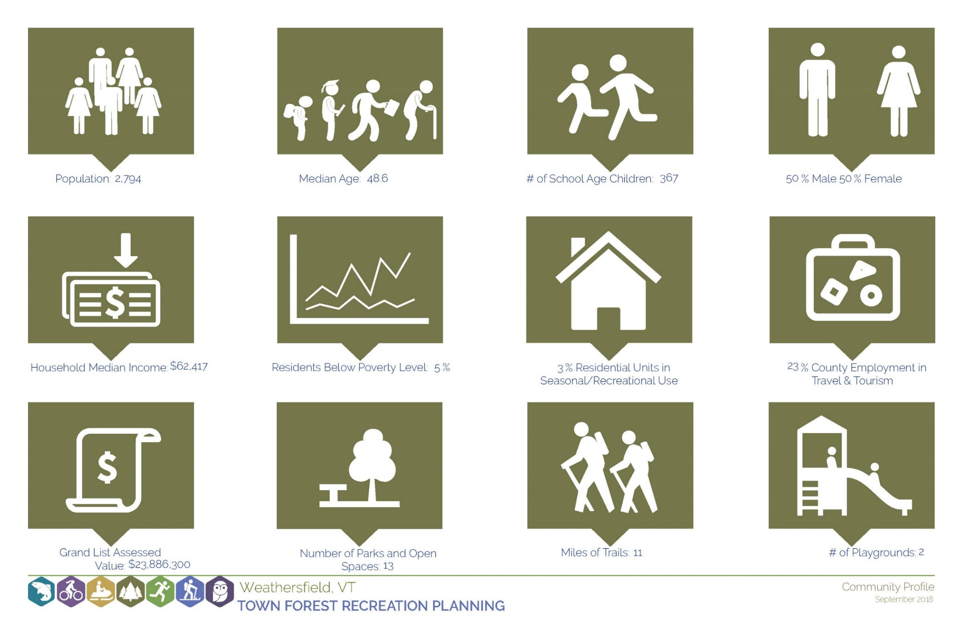
Insert Community Profile

Town Forest Profile

Forest Overview
Insert description of the forest – include acreage, access, trail system, and present uses.

Land Ownership and Conservation Background
Insert description of forest ownership and conservation – include property ownership and history, property management, and conservation easement and management plan if applicable.
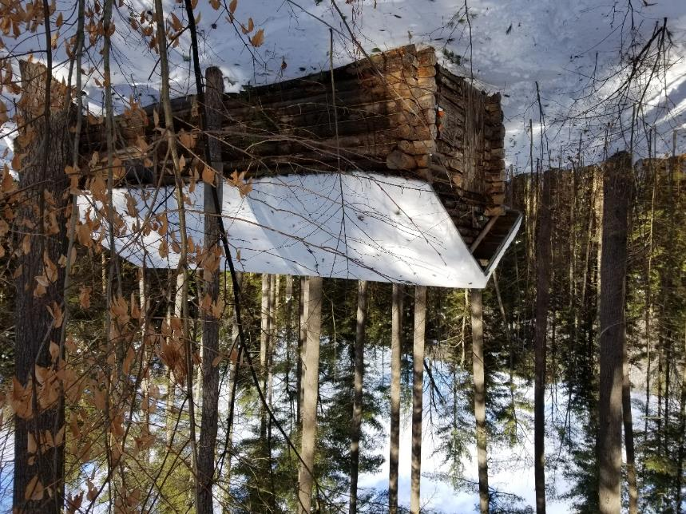
Insert Photo of the Forest
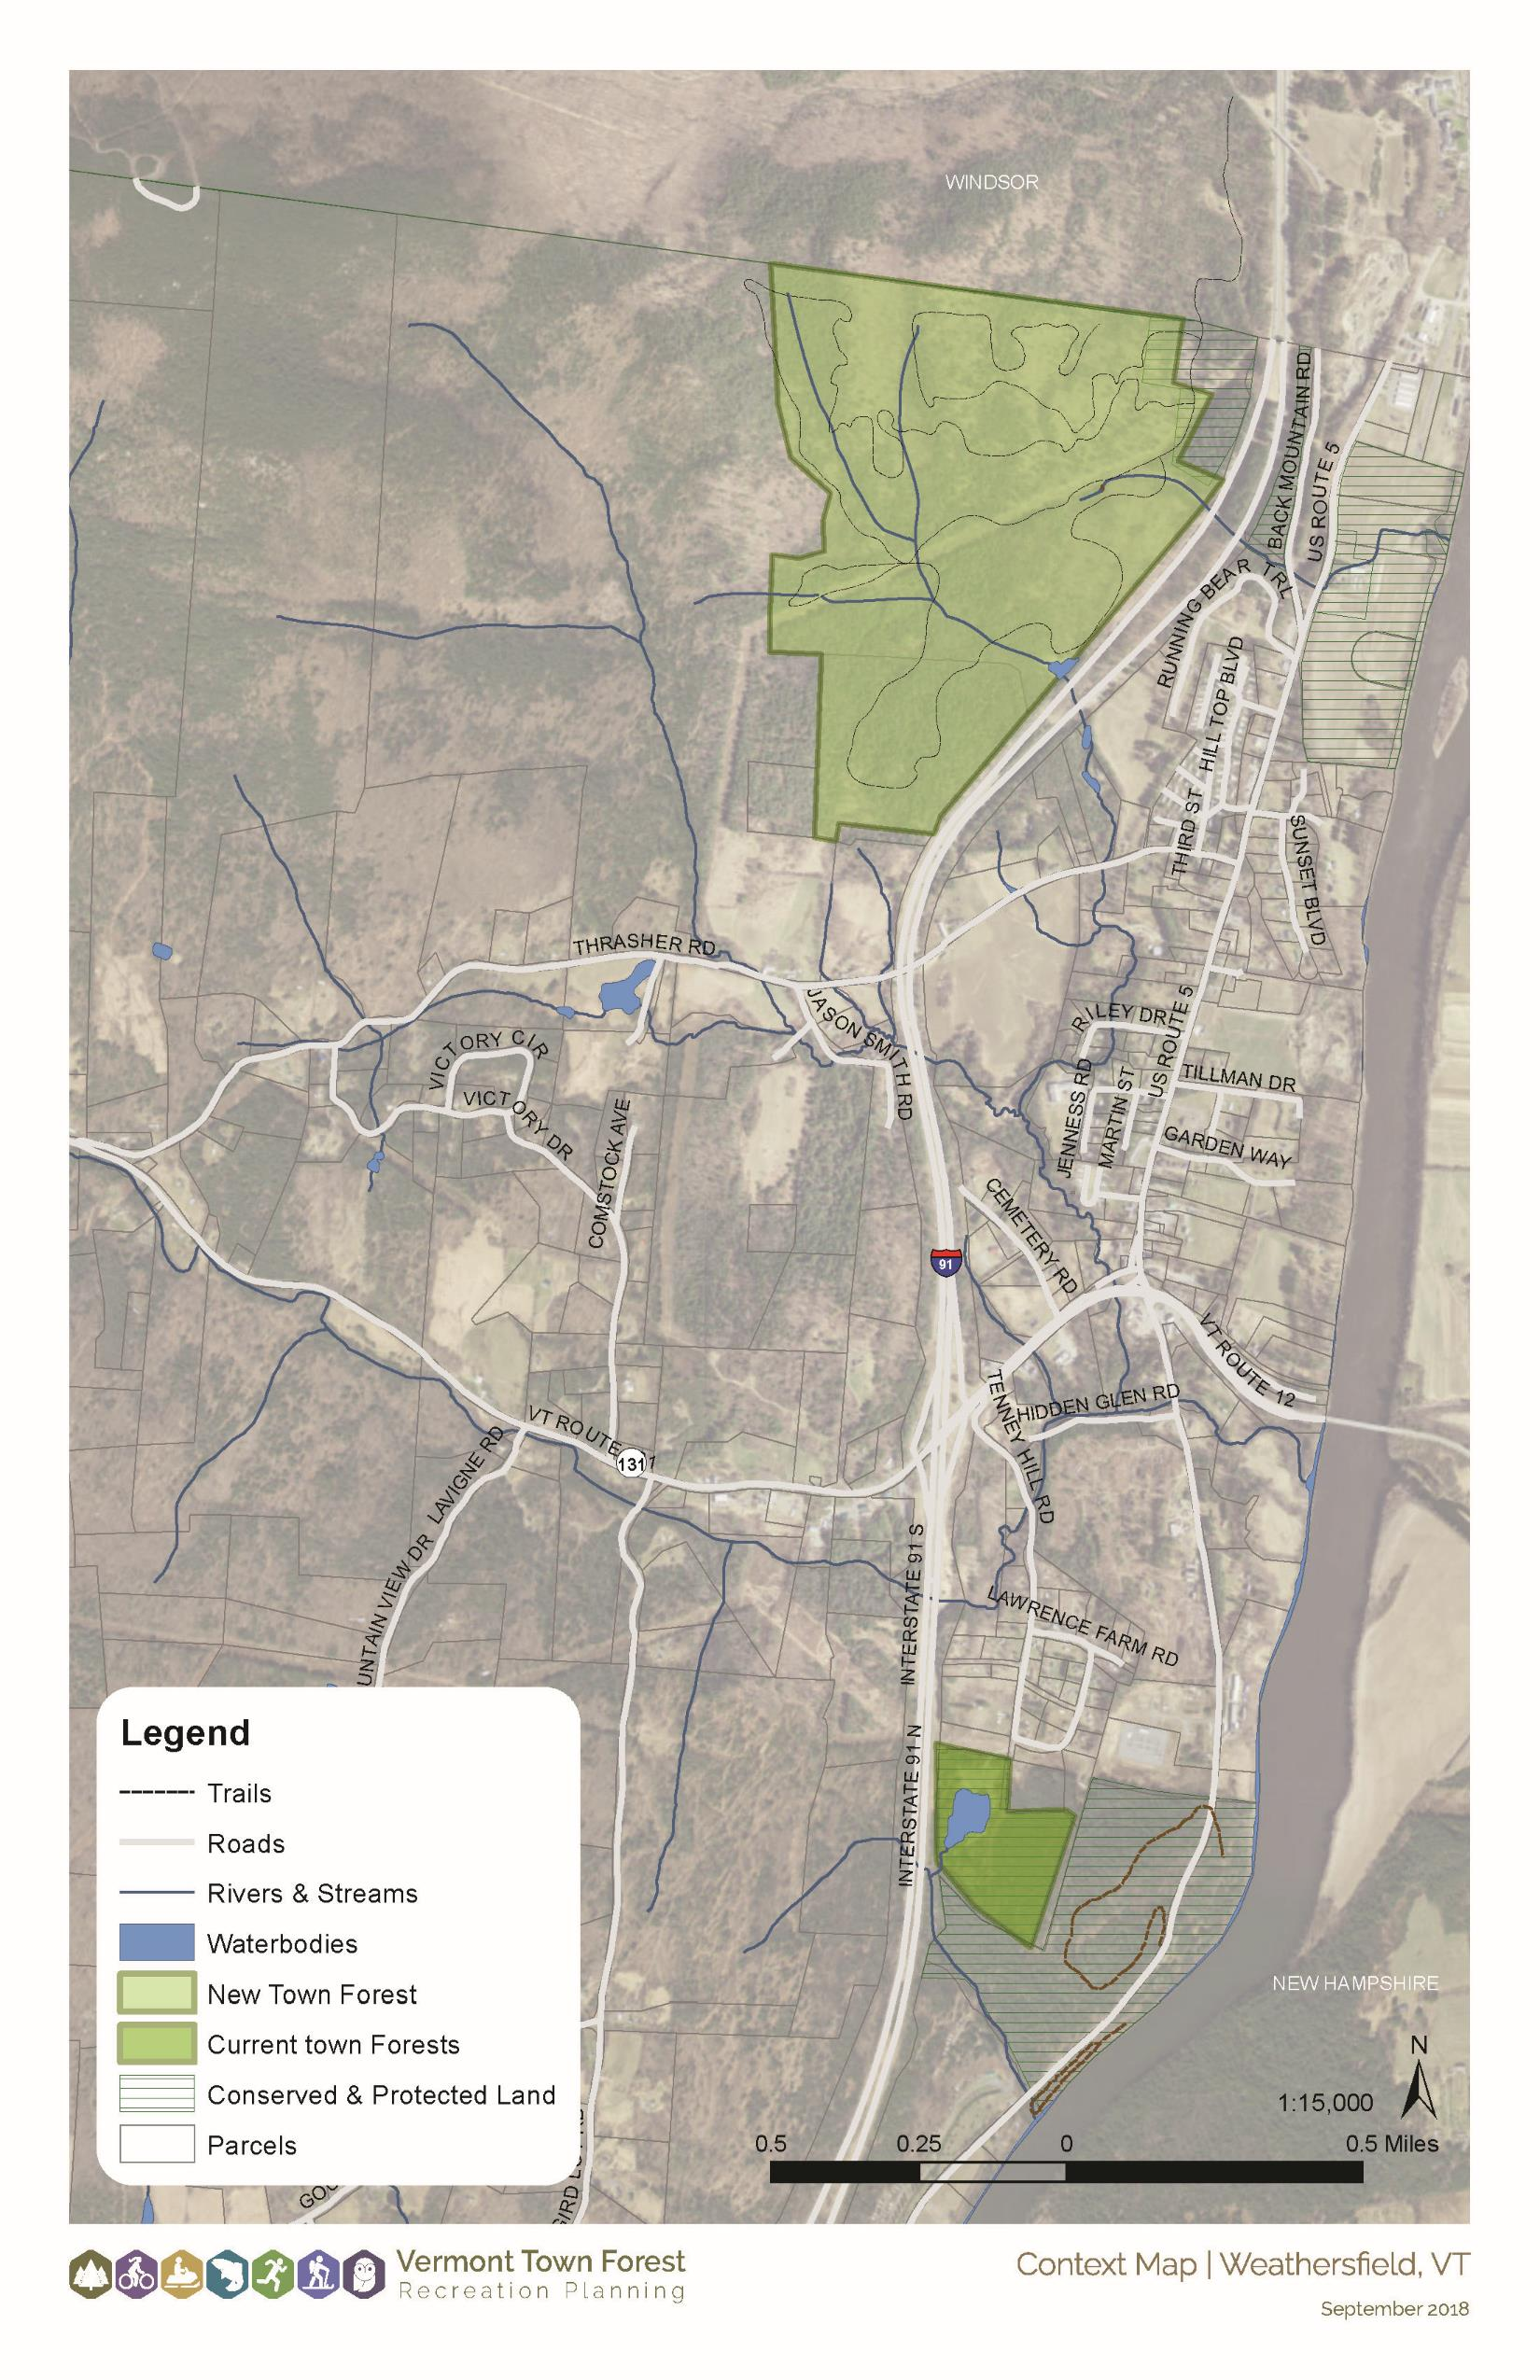

Insert Maps of the Forest
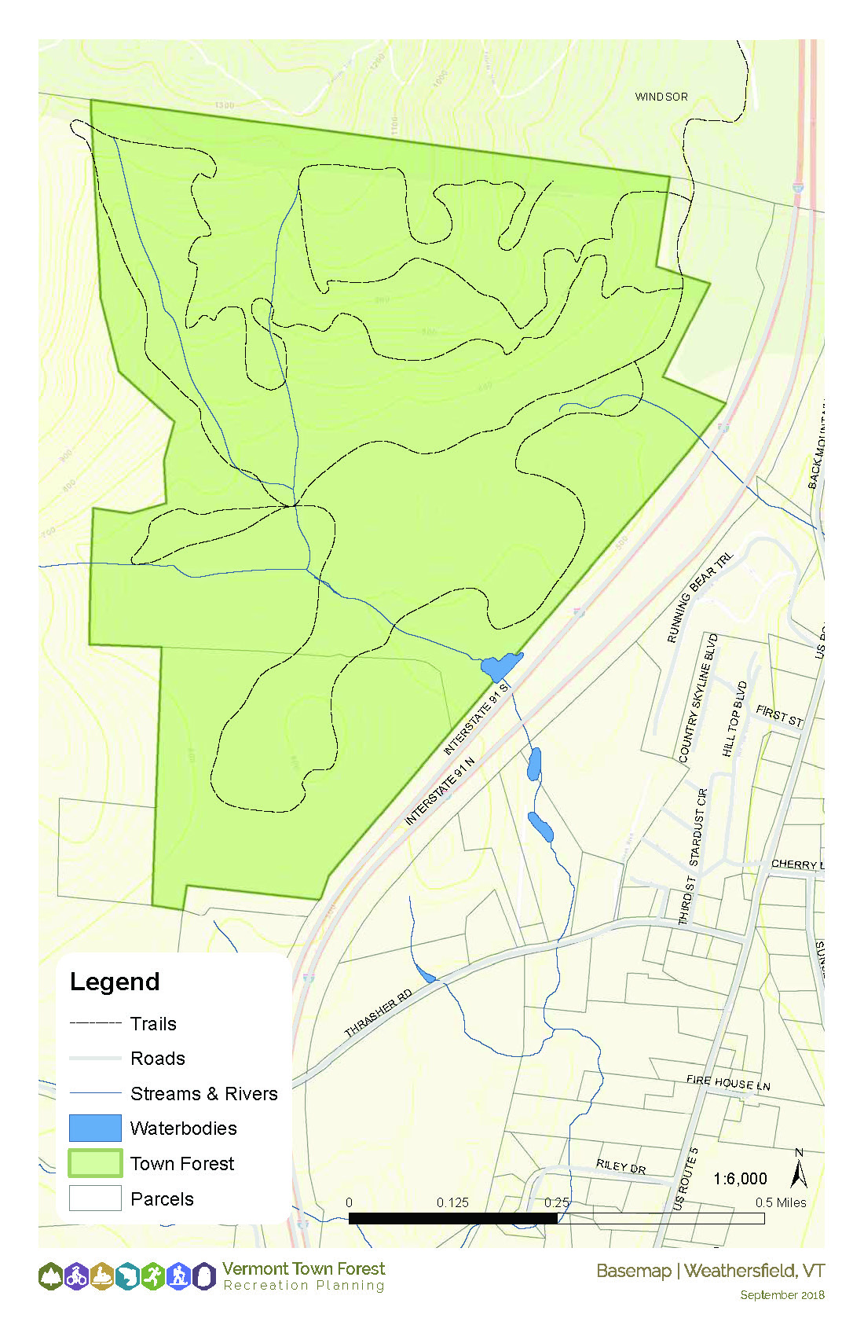
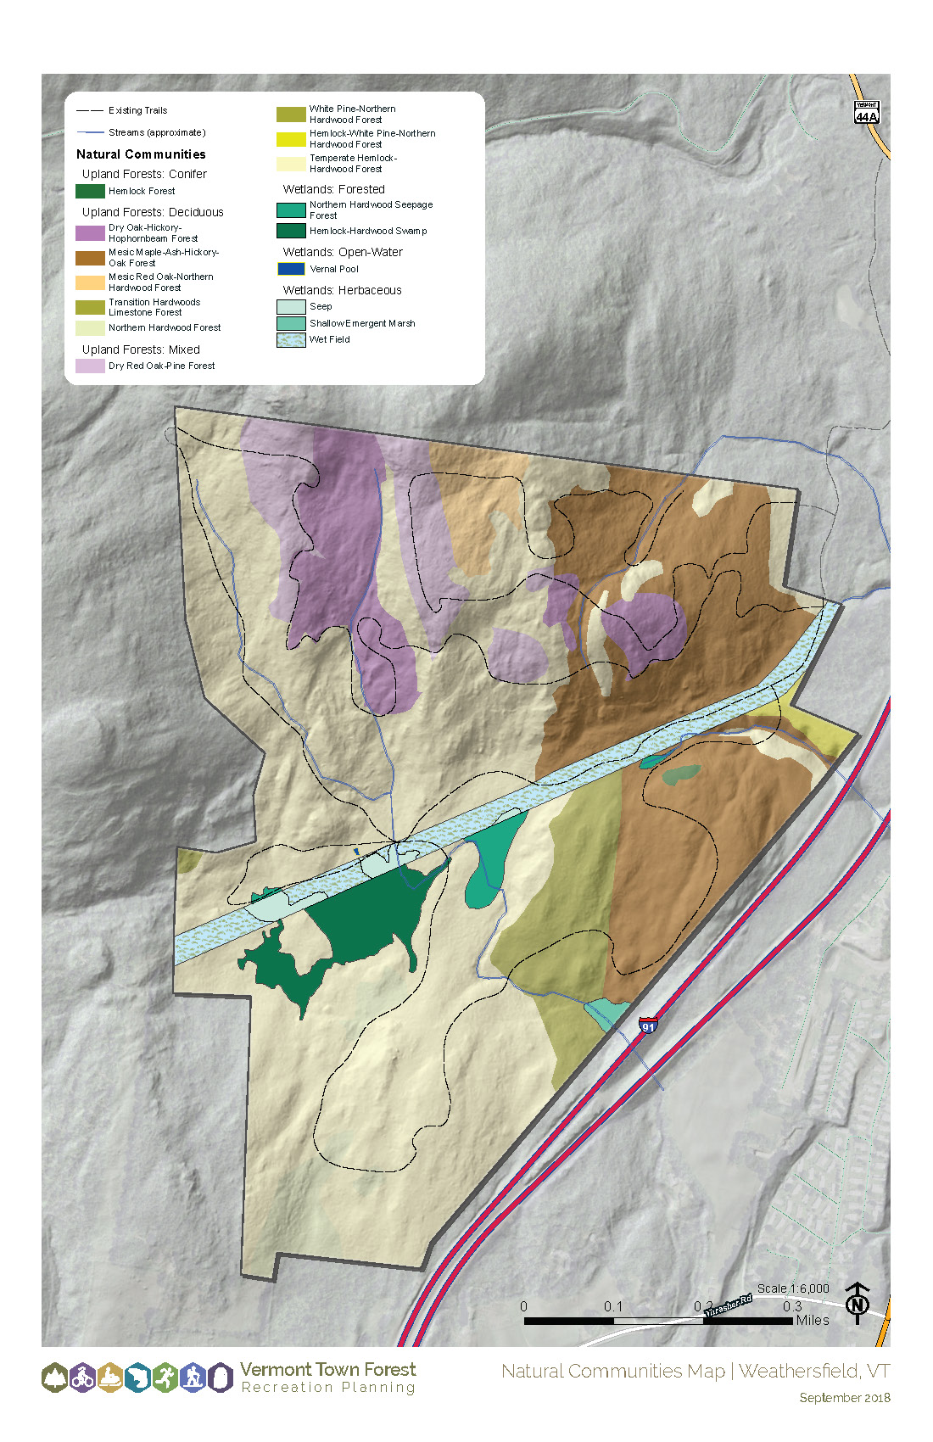

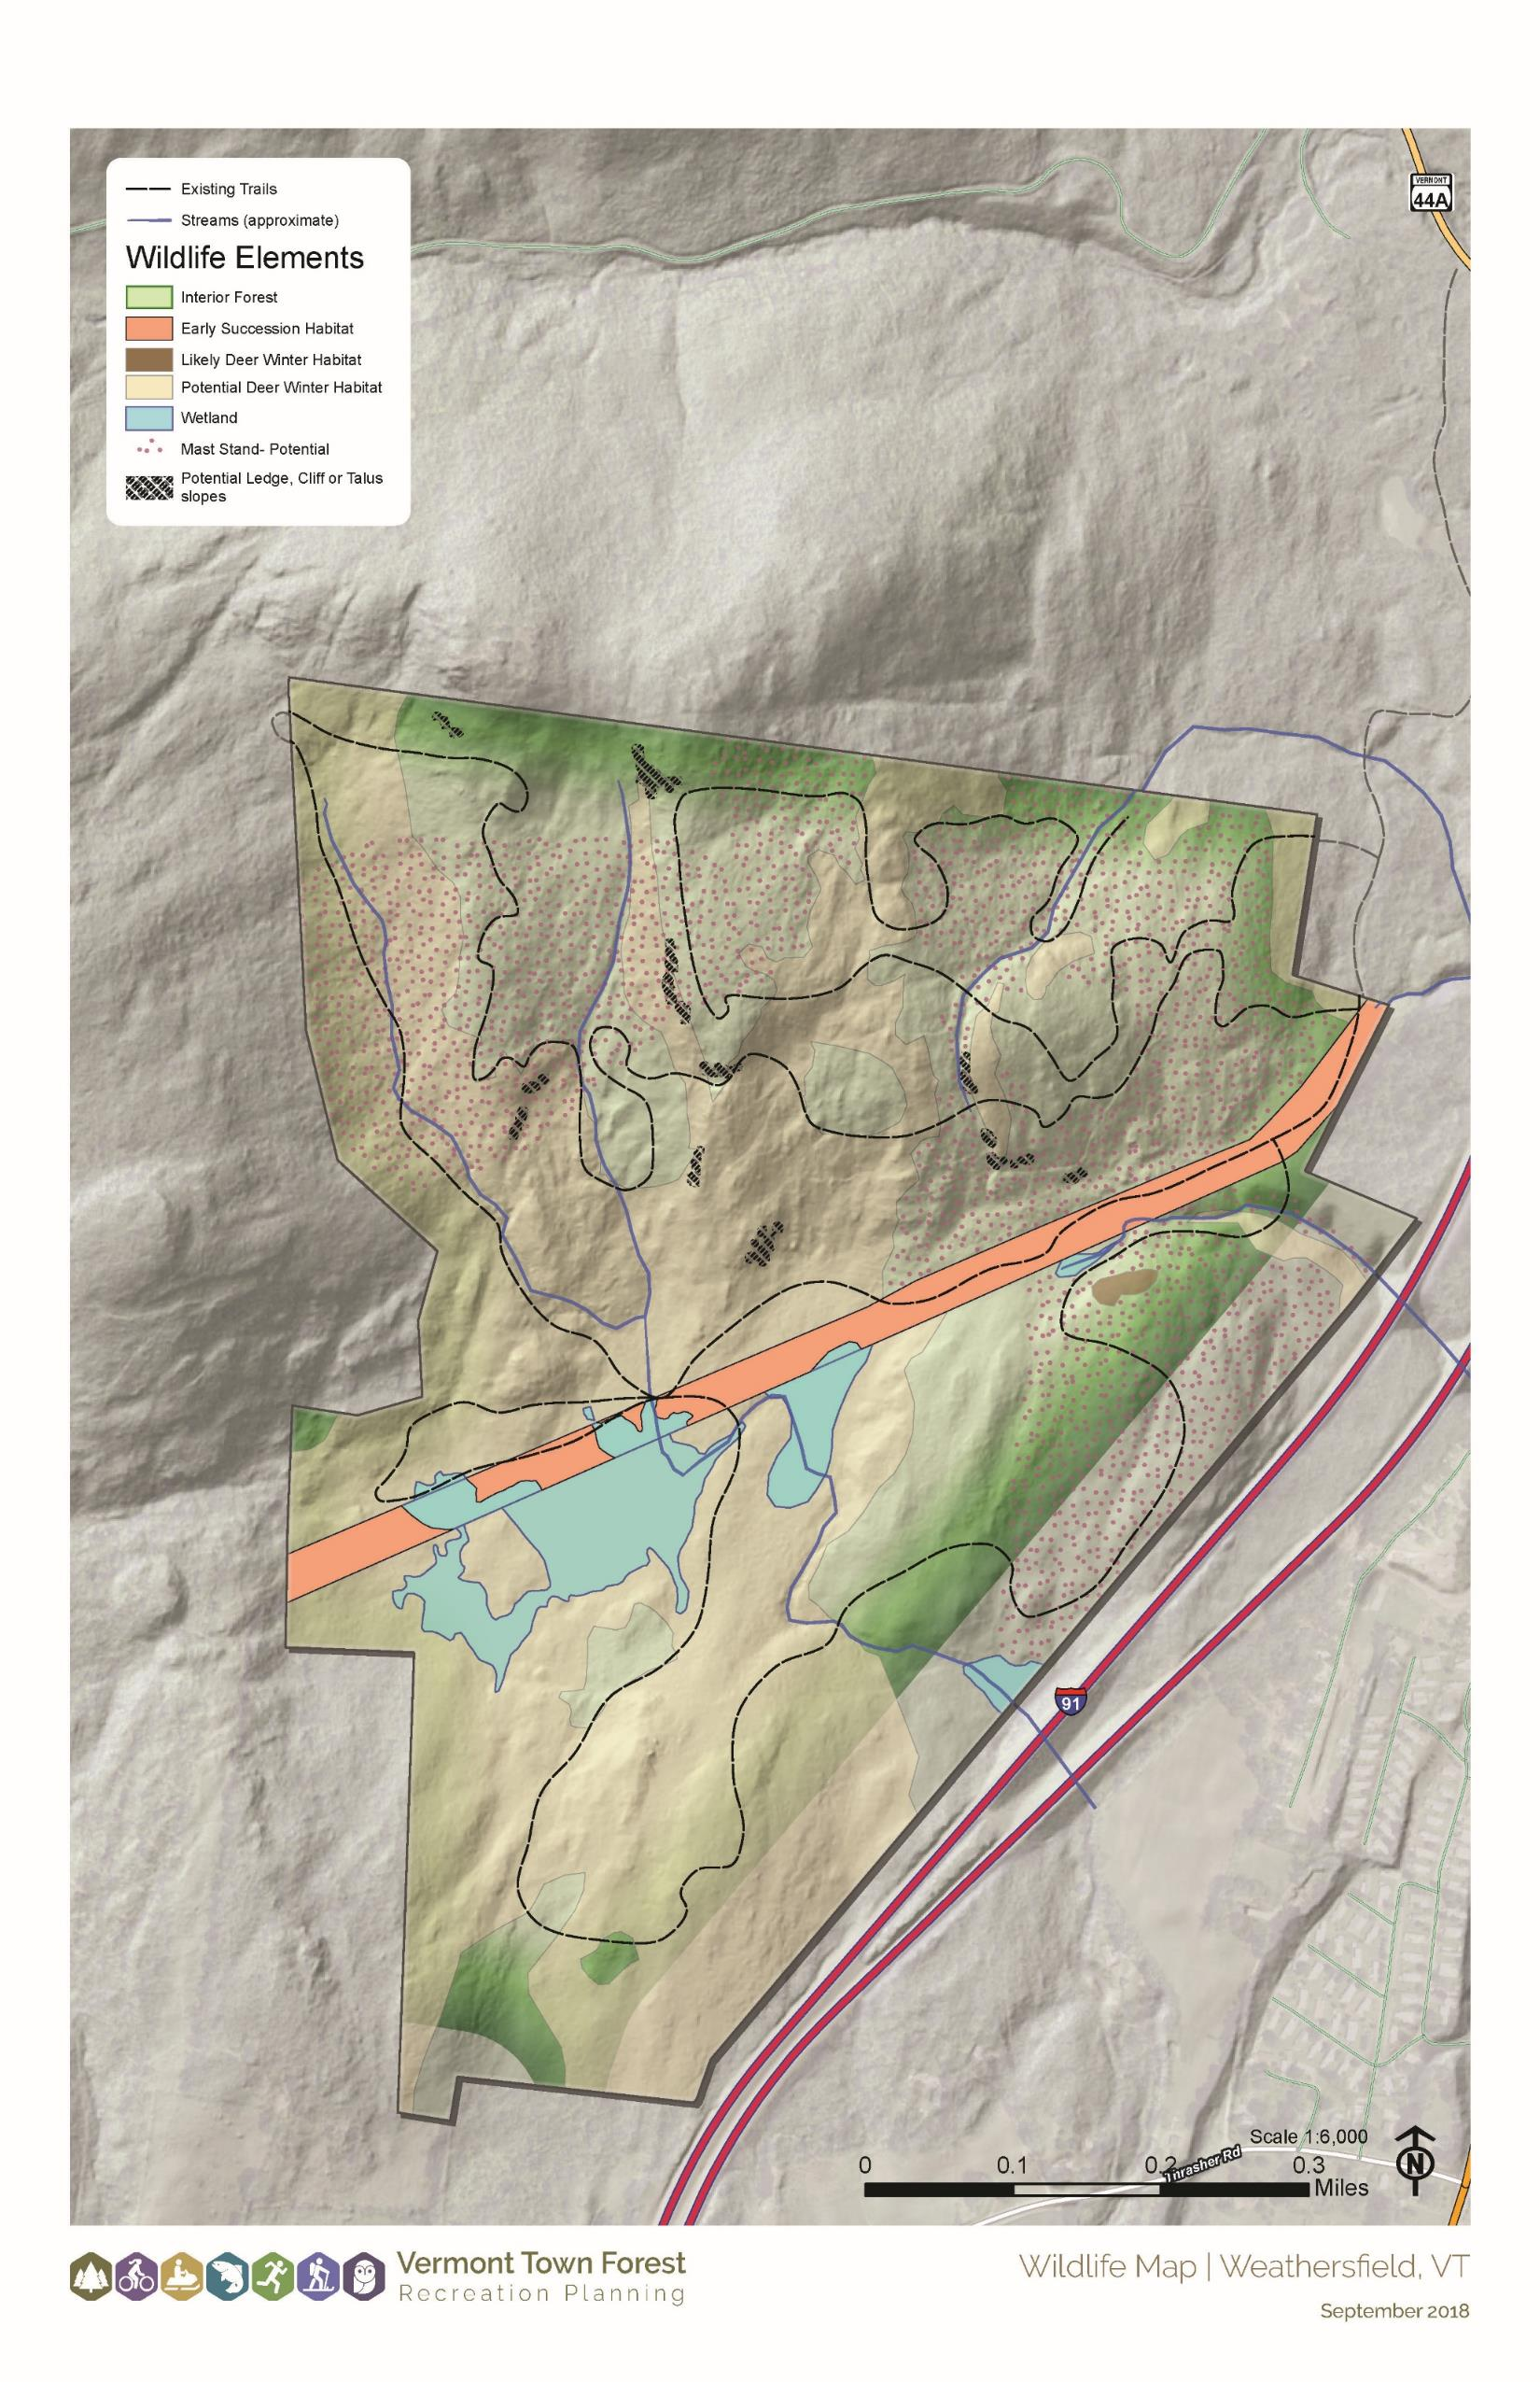

Chapter 3: Public Engagement Summary and Needs Assessment
To bring the “town” into town forest, a robust public engagement process was at the heart of this plan. There were multiple workshops open to the public, a community survey, and many steering committee meetings to guide the plan. Through this process, the public identified issues, needs, desired attributes, and strategies to enhance the forest. The public also offered feedback on the strategies and draft plans, to ensure a fit with the town and forest’s needs, interests, and capacity.

Public Engagement

Steering Committee Process
The steering committee, made up of describe the committee members (conservation commission, town staff, etc.) led this process. Members of the steering committee… describe the process (for example: facilitated public workshops, determined the draft strategies and key attributes of the forest, prepared the draft plan, and met on their own to provide ideas and feedback throughout the process.)

Visioning Workshop
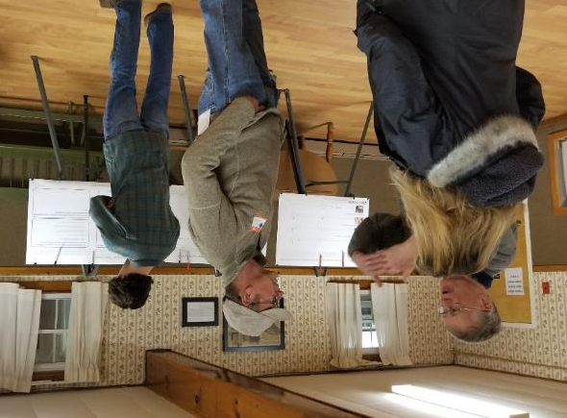
A Visioning Workshop for the XXX Town Forest was held at location on date. The meeting was a drop-in anytime, open house format with questions about an overall vision for the town; the balance of recreation, education, conservation/natural resources, and forest products; the natural resources present on the site; and future activities in the Town Forest. Attendees wrote responses on boards, completed dot exercises, and drew their ideas and knowledge on maps. Members of the local steering committee were available for one-on-one chats with attendees, and a general comment box was provided for open-ended feedback. Background/baseline information about the project, the community, and the forest, was also provided. XX people signed in and an estimated XX people were in attendance.
Please see Appendix 1 – Visioning Process Results, which combines the findings from this meeting and the community survey.

Community Survey
The Community Survey was launched at the public visioning workshop on DATE and remained open through XX. The community survey asked the same questions as the public visioning workshop, in order to give the people who could not attend the meeting an opportunity to provide input. An online survey was made available (if applicable). The community was made aware of the survey through a variety of methods including flyers distributed around town, press releases and news articles, and email blasts and social media posts. In total, the survey received XX responses.
Please see Appendix 1 for the Visioning Process Results, which combines the findings from the Public Visioning Workshop and the community survey.

Strategies Workshop
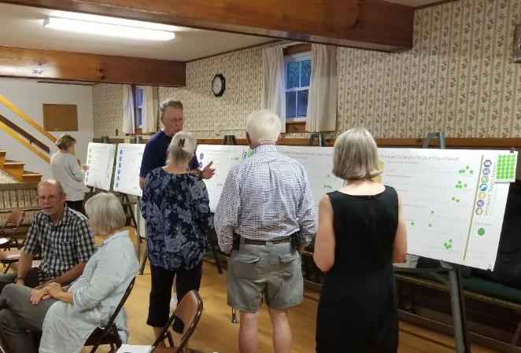
A Strategies Workshop for XX Town Forest was held at the LOCATION on DATE. The meeting was a combination presentation and open house. First, the attendees learned about the project process, the toolkit, vision framework, the management plan, and draft strategies. The meeting transitioned to an open house where attendees prioritized the draft strategies on boards and had the opportunity to have one-on-one discussions with members of the steering committee. Attendees also indicated locations for the draft strategies on a large map. XX people signed in and an estimated XX people were in attendance.
Please see Appendix 2 for the Strategies Workshop Results.

Plan Presentation Workshop
A plan presentation workshop was held at LOCATION on DATE. The presentation was to XXXX and provided XXXX and the public an opportunity to hear the plan and offer feedback. XX people were in attendance.

Needs Assessment
Through the public engagement process, community members identified the issues and needs associated with the forest to be resolved in this planning process. Additional issues and needs were identified via site visits and natural resources assessments. The following issues and needs were identified:
- NUMBERED LIST (Copy from Vision Framework memo)

Chapter 3: Town Forest Vision Framework
A vision framework is a critically important tool that informs the goals and direction of the town forest recreation plan. The vision framework encompasses all forest uses—not just recreation—to understand how recreation should fit in with the community’s overall intent for the forest. The vision framework is directional, descriptive, and aspirational, communicating what the community believes are the ideal conditions for the forest—how things would look if all opportunities and issues were perfectly addressed.
The vision framework includes:
- A discussion of the management balance in the forest; and
- A list of key attributes that describe the community’s desired character for the forest
The vision framework is broad enough to encompass a variety of local perspectives. Unlike a simple one or two sentence vision statement, a vision framework allows for more complexity to be communicated and better illuminates the community’s desired character for the forest—which is often multi-faceted.
The management balance discussion and list of key attributes work together to communicate the community’s overarching aspirations for the forest. Both aspects of the vision framework should align, without repeating each other. The management balance describes the community’s management priorities for the forest, while key attributes are a list of words or short phrases that expand upon the management balance and describe the community’s desired future character for the forest. These two pieces work together and support each other to communicate the multi-faceted values of the community.

Visioning
At the public visioning workshop and in the community survey, attendees/respondents were asked, “What word or phrase best describes your EXISTING experience with the town forest in your community?” and “What word or phrase best describes your DESIRED FUTURE experience with the town forest in your community?” The results of these exercises are demonstrated in the word clouds below. The size of the words in the word clouds corresponds to the number of times that word was used in the responses.

Existing Experience
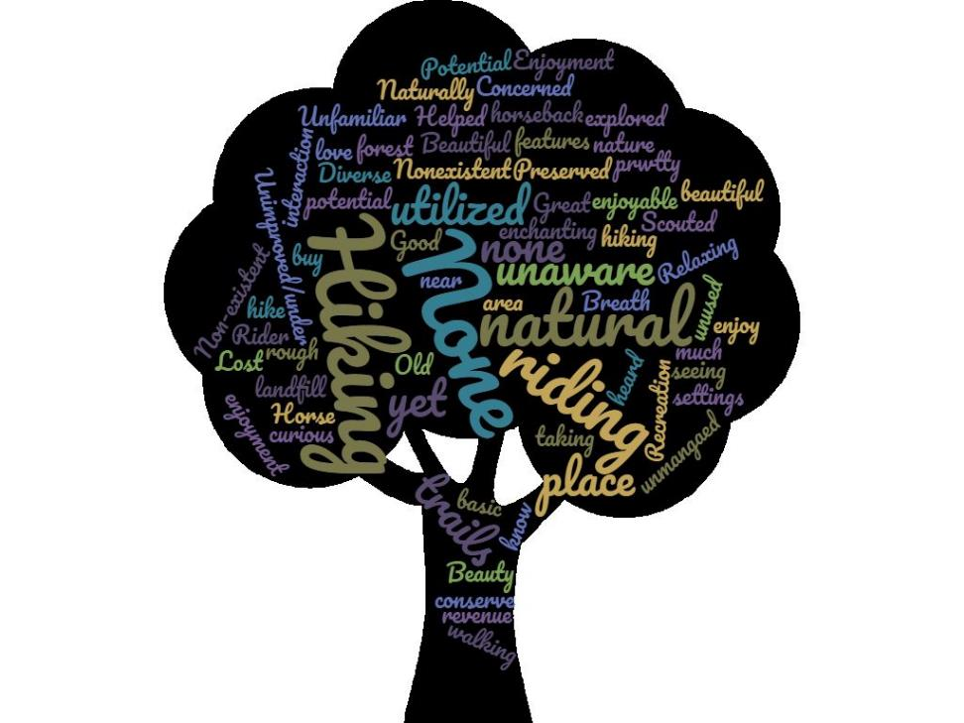
Insert word clouds created in visioning workshop results document
Insert 2-4 sentences of takeaways and summary from the above word cloud. What were the most common words or themes?

Desired Future Experience
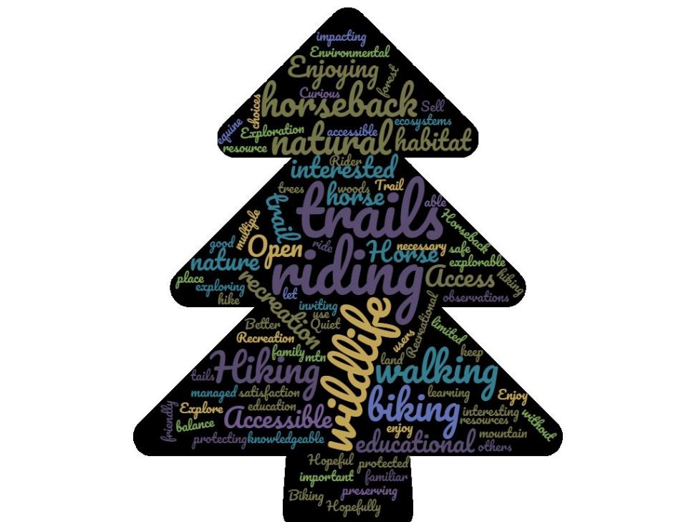
Insert word clouds created in visioning workshop results document
Insert 2-4 sentences of takeaways and summary from the above word cloud. What were the most common words or themes?

Management Balance
Town Forests can be managed to provide a wide range of activities and community values. Four common use areas include Recreation; Education & Land Use Demonstration Projects; Natural Resources & Habitat; and Timber & Forest Products. While most publicly accessible forests provide some measure of all four types of uses, they tend to “lean” in one management direction or another.
To understand the desired balance for XXX Forest, the steering committee considered this internally throughout the Visioning Process and asked survey and workshop participants “Where do you think the management focus SHOULD fall for the Town Forest in your community? Should it lean towards Recreation, Education, Timber & Forest Products, or Natural Resources & Habitat?” Their responses are below:
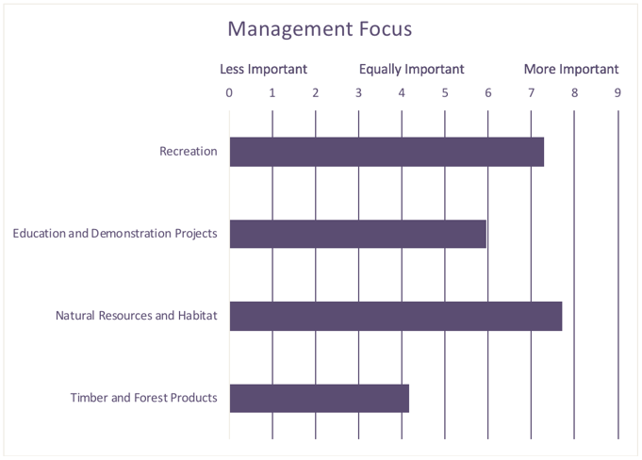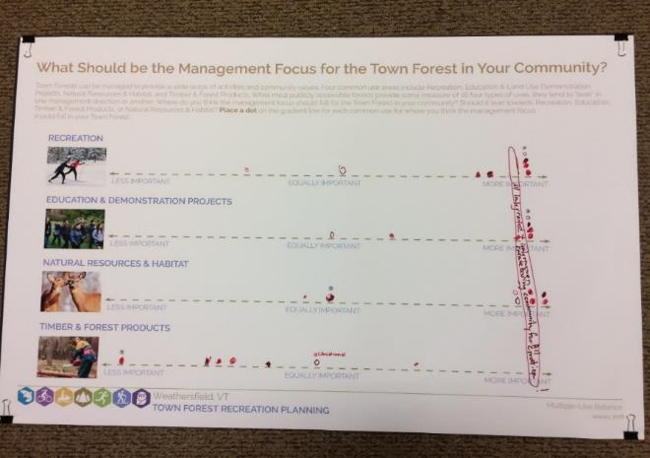
Insert photo of workshop boards results
Insert chart of survey results
Insert summary of management balance results. Include committee’s analysis of these results.

Key Attributes
The following list of key attributes are the words or short phrases that communicate what the community believes are the ideal conditions for the forest – how things would look if all opportunities and issues were perfectly addressed, which may be the same or different from how things currently look. This list is based on the analysis of public and committee input received through the visioning process, as well as the review of the community’s demographics, profile, forest information, current management plans, and surveys.
- Insert List (From key attributes selected in the vision framework memo)

Chapter 5: Action Plan

Introduction
The Action Plan is a set of recommended strategies and projects to achieve the town’s vision. These strategies and projects were developed based on the key attributes, needs assessment, forest walks, and input from the steering committee and community. From a larger initial list of strategies, the steering committee has selected and edited the strategies to craft an action plan well-suited to the community’s interest, needs, and capacity.
The Action Plan includes a list of highest priority strategies, an Action Plan map to graphically display the highest priority strategies, and an Action Plan Table

High Priority Projects
List the 5-10 highest priority strategies as a result of the draft strategies workshop and the committee’s thinking

Action Plan Graphic
The following diagram shows conceptual locations for the high priority strategies with a spatial component. These locations are based on the community’s pinpointing of strategies at the workshop, the natural resources of the forest, the facilitated forest walks, and the project team’s understanding of the right spacing and locations for these strategies. The locations on this map are generalized and, in most cases, further planning and design will be necessary before construction.
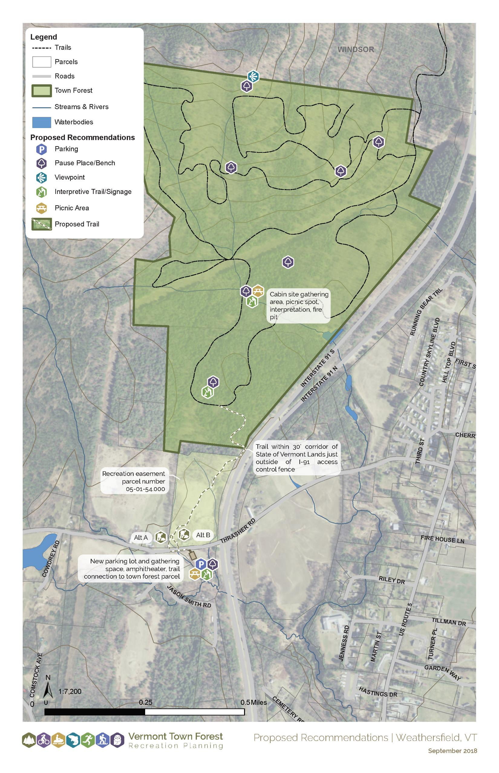
Insert Bubble Diagram of top priority strategies

Action Plan Table
The Action Plan Table on the following pages includes all the strategies for the town and additional information to help with implementation. The strategies were categorized under Parking & Access; Trails; Other Facilities & Structures; Education & Programs; Events; Maps, Outreach, and Promotion; and Administrative Actions. Each strategy has the following additional information:
  - A detailed strategy description
  - Responsibility – who the responsible parties are to pursue this strategy (i.e., Town, Conservation Commission)
  - Timing (ongoing, short, medium, long-term) – when the responsible party should begin pursuing this strategy
  - Partners involved – possible partners to be involved in this project (i.e., Vermont Land Trust, Vtrans, local trails groups, local schools)
  - Planning required – planning, designs, assessments, or studies that needs to happen before this strategy can be pursued (i.e., trail system design, wildlife habitat assessments)
  - Relative Cost ($,$$,$$$,$$$$) – a ballpark estimate of what the project will cost. One dollar sign is little to no cost, two dollar signs is moderate, three dollar signs is more expensive, four dollar signs is very expensive. $-$$ indicates the relative cost is between those two levels. $/$$ indicates that the project can be either $ or $$, depending on the chosen route (i.e., volunteer trail counts vs. electronic trail counter)
  - Funding Opportunities – potential sources of funding for the project. These could be grants, local business sponsorships, or fundraising events
  - Toolkit and Support Resources – the toolkit elements that provide guidance on pursuing this strategy. Guidance from Vtrans, the Vermont Town Forest Stewardship Guide, or other support resources can also be useful to pursue this strategy

Strategy or Action | Description | Responsibility | Timing  (Ongoing, short, medium, and long-term) | Partners Involved | Planning required | Relative Cost  ($-$$-$$$-$$$$) | Funding Opportunities | Toolkit & Support Resources
1. Parking & Access
Fill in Strategies or copy and paste from excel
2. Trails
3. Facilities and Other Structures
4. Education and Programs
5. Events
6. Mapping, Outreach, and Promotion
7. Administrative Actions

Chapter 6: Implementation

Town Forest Recreation Planning Toolkit
The Vermont Town Forest Recreation Planning Toolkit was developed through the overall US Forest Service grant. The intent behind the toolkit was to build up a replicable process and a set of tools that could be used for both the professionally-facilitated process with the first ten communities, and for other towns like ours to do our own recreation plans after this pilot project ended.
Importantly for our town, the toolkit includes a number of guidance documents, designs, case studies, best practices, and standards the Town can use to implement strategies identified in this plan. The action plan table and detailed project pages identifies the most relevant toolkit resources for each strategy. In addition, the full list of toolkit resources is described below.
The toolkit is organized through six (6) specific “pods.” These include an existing conditions and assessment pod, a public engagement pod, a natural resource pod, a plan development pod, an implementation pod, and a stories pod. Each are described below.
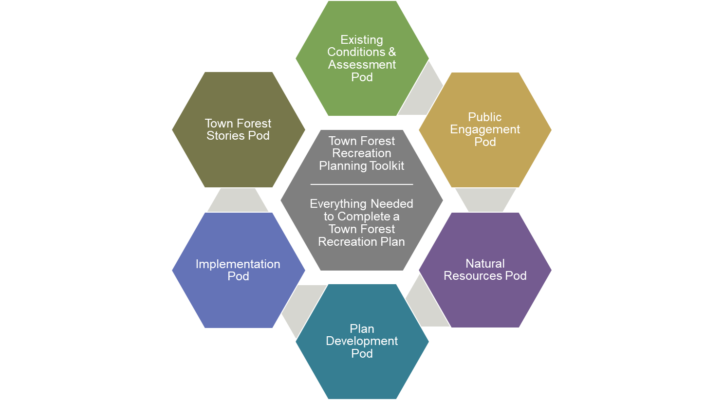
The Vermont Town Forest Recreation Planning Toolkit is available on Urban and Community Forestry’s website at: https://vtcommunityforestry.org/

Existing Conditions Pod
The existing conditions and assessment pod provides a checklist to communities to identify background information and municipal plans that should be considered in developing their plan. This pod also includes trail counting forms and extrapolation sheets modified for Vermont from the National Bike and Pedestrian Documentation Project materials. Trail and facility assessment checklists are also included, so the baseline conditions of the town forests can be well understood. Information about available resources such as VT UCF and the county foresters are also provided. Instructions on how to use the VT Center for Geographic Information (VCGI) interactive map viewer to produce basic maps is also included in this pod.
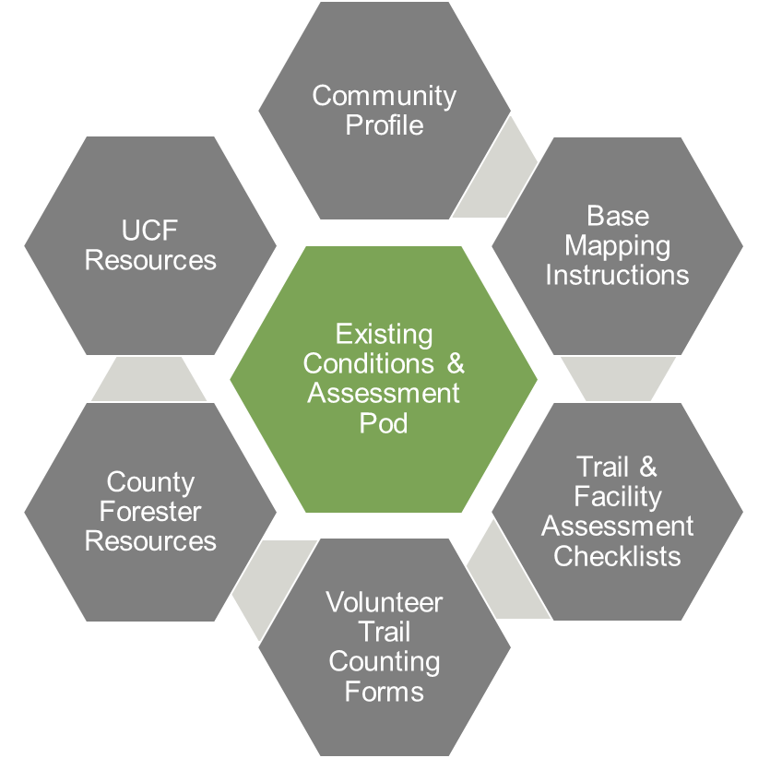

Public Engagement Pod
The public engagement pod provides a series of promotional material templates, such as flyers and press releases, and public meeting materials, like informational boards and handouts, that communities can use to explore concepts and constraints with the public. Informational board templates provide opportunities to both present information and gather feedback through write in questions, dot exercises and similar interactions. Surveys and visioning materials that allow towns to identify their priorities for use of their forests are an integral part of this pod. Finally, guidance and best practices on how to facilitate steering committee and public meetings round out the range of materials available in this pod.
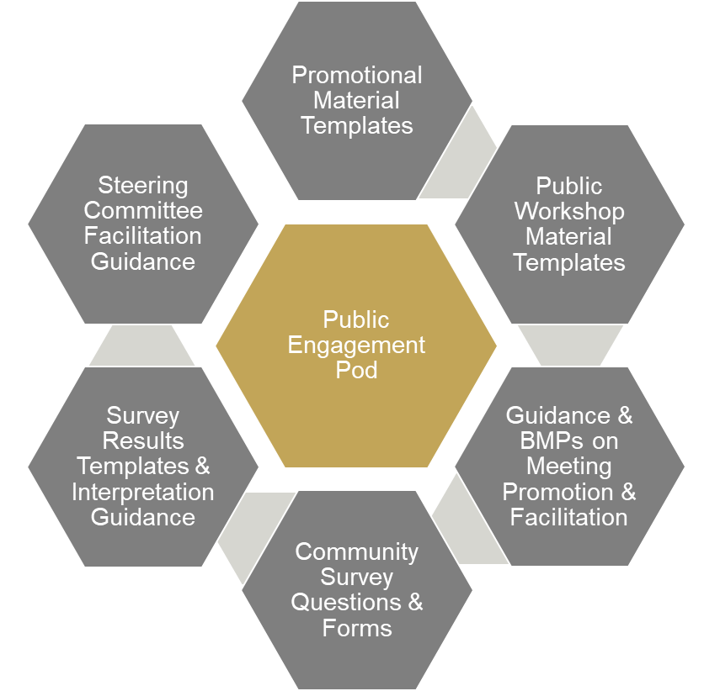

Natural Resources Pod
The natural resources pod, developed by Arrowwood Environmental, includes guidance for using ANR’s Natural Resource Atlas for general resource mapping, a process for inventorying natural resources in the forest, workshop and survey questions for natural resources, and a model process for proposing and evaluating new trails or facilities. Most importantly, the natural resources pod also includes the Natural Resources Guidebook and associated activities and resources matrix. The guidebook includes information and links to relevant regulatory documents and contact information at both the State and Federal level for each of the following natural resource areas: Vernal Pools, Deer Wintering Areas (DWA), Ledges/Cliffs/Talus, Mast Stands, Interior Forest, Significant Natural Communities, Wetlands, Rare, Threatened or Endangered Species, Floodplain Forests, Streams/Rivers, Early Succession Forests, and Lakes and Ponds. The guidebook also includes an activities matrix for each of these resources that provides compatibility, management information and recommended buffers for a range of activities and facilities, including: Hiking Trails, Biking Trails, X-C Ski Trails, ATV trails, Snowmobile Trails, New Access Roads, Structures/Buildings, Parking Lots, Forestry/Logging, Camping, Sugaring, and Extraction (gravel, sand).
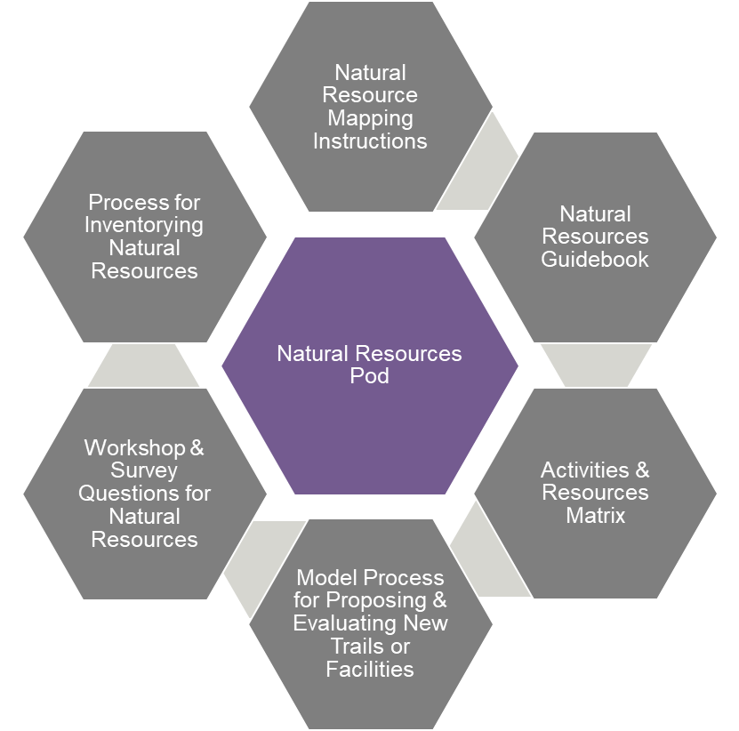

Example Content from the Natural Resources Guidebook

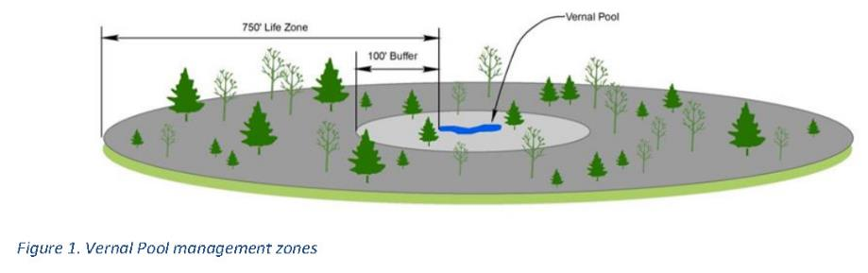

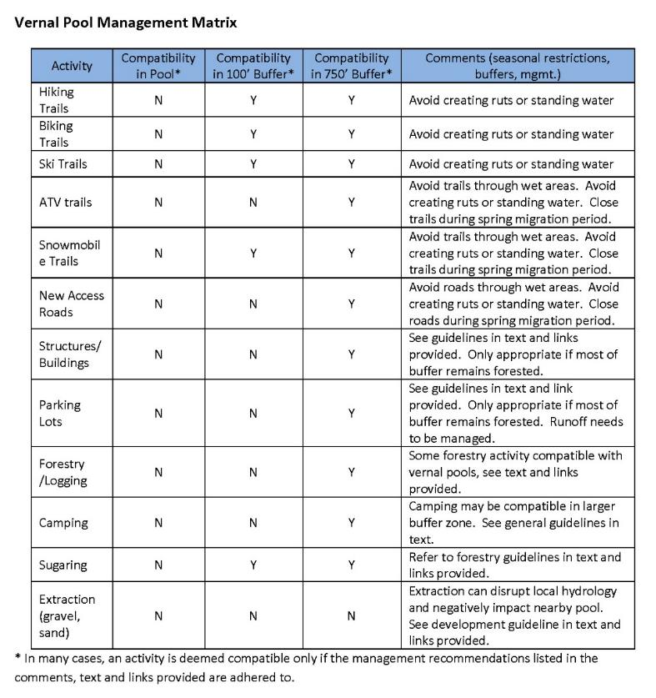

Plan Development Pod
The plan development pod can help facilitate the development of a Town Forest Recreation Plan by other interested communities, or update this existing recreation plan. The pod includes templates and guidance on crafting a vision statement for a town forest as well as case studies of each of the 10 selected communities and their plans highlighting the process they undertook. The plan development pod also includes a recreational improvements strategy database that allows communities to search sample implementation actions based on resources, topics or activities. This database includes all strategies contained in the 10 established plans, and their relative cost. Template action plan tables and bubble diagram map guidance is also included.
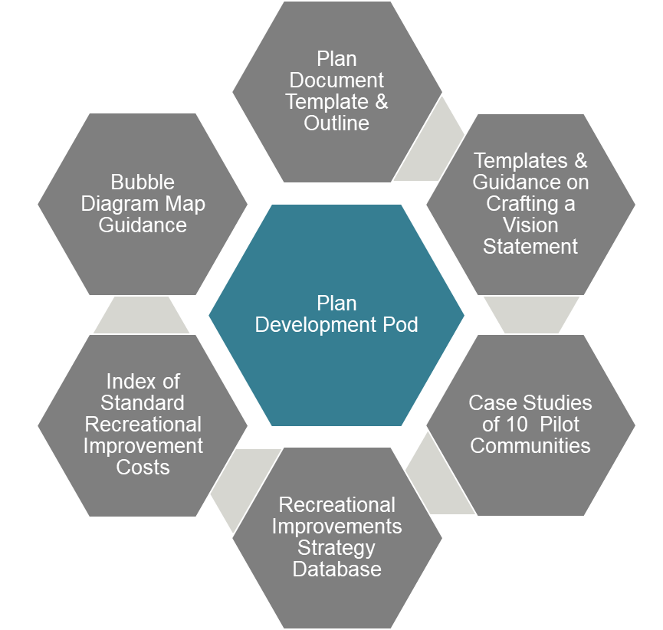

Implementation Pod
The implementation pod contains a number of tools to aid in implementation of this plan. In addition to a list of available grant, funding and support resources relevant to town forests, the pod also includes grant writing best practices to help make sure you get the necessary funds to move forward. Design guidance and standards for building sustainable trails and facilities for a wide range of user types is also provided. Guidance on acquiring additional lands or easements is also included. Volunteer designs, materials lists, and construction instructions are also provided in this pod.
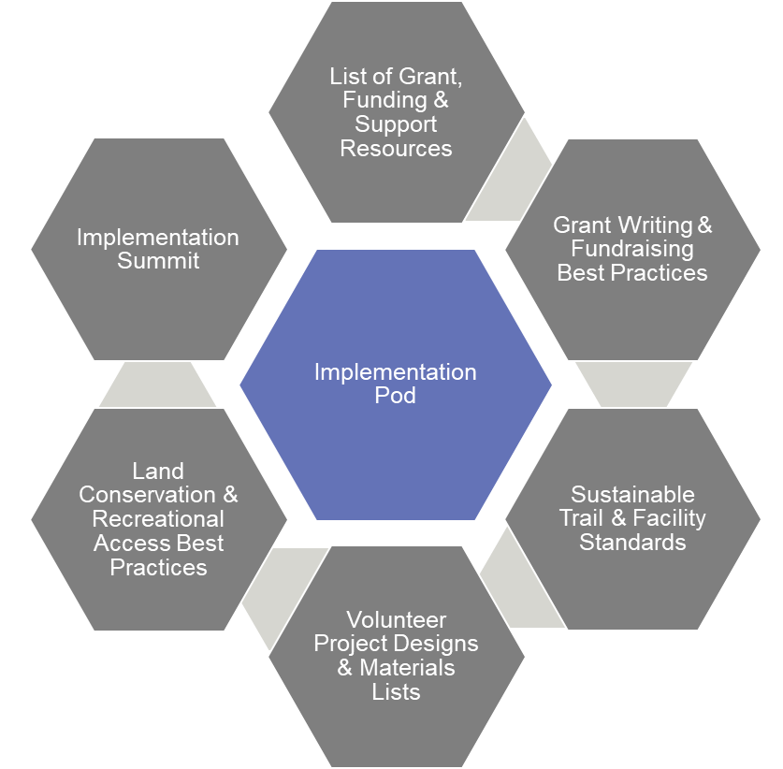

Town Forest Story Pod
The town forest story pod incudes personal narratives and how-to webinars from participants in the 10 town forest process on what it actually takes to be a volunteer managing a town forest in your community. The stories share tips, tricks, and pitfalls to help keep you on course, as told by others in the same role!
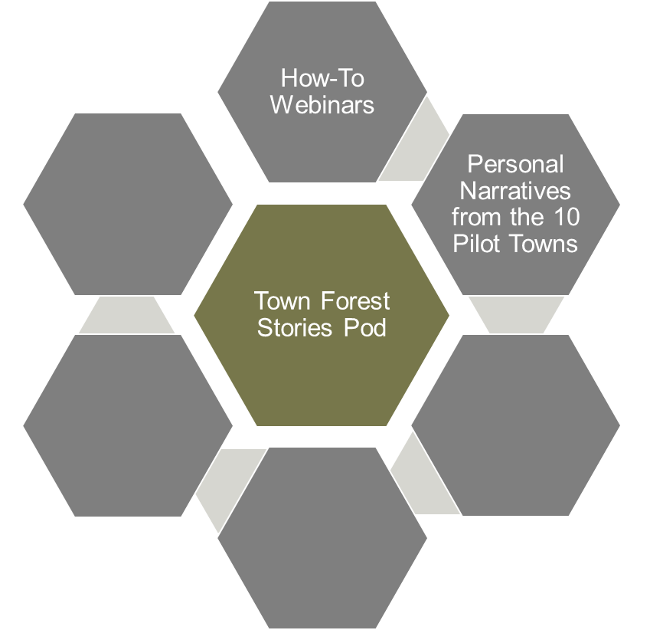

Grants and Funding Sources
For most of the strategies and projects in this plan, moving them forward will require financial resources. Luckily, our town and its budget do not have to go after it alone. There are many grants and alternative funding sources that can help provide the necessary funding. Perhaps the best approach to move a project forward is to select a project with strong community support, secure grant funding, and leverage local resources and volunteers.
The description of each grant below suggests the types of projects the grant funds, the required match from the town if necessary, and a link for more information. Some grants have been identified in the Implementation Matrix using their respective abbreviation.

Federal and State Grants and Programs

Land and Water Conservation Fund State and Local Assistance Program (LWCF)
The Land and Water Conservation Fund (LWCF) state assistance program provides matching grants to help local communities enhance the outdoor recreation resources on public land. LWCF funding has benefited nearly every county in America, supporting over 40,000 projects. The grants create parks and open spaces, protect wilderness and forests, and provide outdoor recreation opportunities. Eligible projects are acquisition of land for parks and public outdoor recreation or development and/or renovation of existing facilities for outdoor recreation. This 50:50 matching program is the primary federal investment tool to ensure that families have easy access to public, open spaces. In Vermont, LWCF is administered by Vermont Department of Forests, Parks & Recreation.
http://fpr.vermont.gov/recreation/grants/lwcf

Surface Transportation Block Grant Program (STBG)
The State Surface Transportation Program (STP) is the main program of Federal Transportation Funds, managed by VTrans, for transportation improvements on state highways. Possible projects include recreational trails, pedestrian and biking enhancements, sidewalks, and signed routes.
https://www.fhwa.dot.gov/specialfunding/stp/

USDA Rural Development Loan and Grant Assistance (RD)
USDA Rural Development (RD) forges partnerships with rural communities (defined as towns and villages with less than 20,000 inhabitants), funding projects that bring housing, community facilities (including trails and active transportation facilities), business guarantees, utilities and other services to rural America. This program provides funding to develop essential community facilities in rural areas. An essential community facility is defined as a facility that provides an essential service to the local community for the orderly development of the community. Relevant to this plan, possible projects include transportation facilities, parks, and community gardens
http://www.rd.usda.gov/programs-services/community-facilities-direct-loan-grant-program

National Park Service Rivers, Trails, and Conservation Assistance Program (RTC)
The National Park Service Rivers, Trails, and Conservation Assistance (RTC) program supports community-led natural resource conservation and outdoor recreation projects across the nation. Their national network of conservation and recreation planning professionals can partner with community groups, nonprofits, tribes, and state and local governments to design trails and parks, conserve and improve access to rivers, protect special places, and create recreation opportunities. Current projects include trail rehabilitation, interpretive trails, connector trails, trail master plans, trails collaboratives, and rail trail connectors. No monetary grants are made.
https://www.nps.gov/orgs/rtca/index.htm

FHWA Recreational Trails Program (RTP)
The Recreational Trails Program (RTP) provides funds to communities for development and maintaining recreational trail projects. Grants are awarded to well-planned projects that help to develop, protect, and maintain trails and trail systems that improve connections in the community, livability, user-ability, and are maintained for public recreational use. RTP funds support a wide range of trail activities including hiking, mountain biking, walking, running, cross-country and backcountry skiing, nature-based interpretive trail use, equestrian, snowmobiling, and off-road motorized recreation. Funds can be used for the following types of projects: construction of new trails or trail connections; construction of new trailhead areas/parking facilities; construction of trailside facilities; maintenance, renovation, or restoration of trails; improvements to signage or trail structures along the trail; assessments of existing trail conditions for accessibility and improvements; equipment; and trail-related educational projects (i.e., information about trail safety, appropriate trail use, environmental protection, etc.). The program is administered by the Vermont Department of Forests, Parks and Recreation in the Agency of Natural Resources, in cooperation with the Vermont Agency of Transportation.
http://fpr.vermont.gov/recreation/grants/rtp

Transportation Alternatives Program (TAP)
The Transportation Alternatives Program (TAP) is a grant program administered by VTrans that provides funding for programs and projects defined as transportation alternatives, including on- and off-road pedestrian and bicycle facilities, sidewalks, and bicycle infrastructure. These funds will cover a maximum of 80% of the project with the remaining portions most likely coming from the project-sponsoring organization or town. The FY 2019 funds are reserved for environmental mitigation projects.
http://vtrans.vermont.gov/highway/local-projects/transport-alt

VTrans Bicycle and Pedestrian Program (BPP)
The Vermont Bicycle and Pedestrian Program (BPP) provides funds managed by VTrans for scoping, design, and construction of bike and pedestrian facilities, sidewalks, shared-use paths, and bike lanes. A local match is required but varies based on the type of project.
http://vtrans.vermont.gov/highway/local-projects/bike-ped

Vermont Community Development Program (VCDP)
The Vermont Community Development Program provides Community Development Block Grants (CDBG) to all Vermont towns and cities, aside from Burlington. The grant provides financial and technical assistance to identify and address local needs in housing, economic development, public facilities, public services, and handicapped accessibility modifications. The four types of grants are Accessibility Modification Grants (AM), Implementation Grants (IG), Planning Grants (PG), Scattered Site Grants (SS). These grants must primarily benefit persons of low and moderate incomes.
http://accd.vermont.gov/strong_communities/opportunities/funding/vcdp

State Grants and Programs

Vermont Community and Urban Forestry Council Grants (Caring for Canopies Grants, CCG)
These Caring for Canopies Grants (CCG) are awarded to municipalities to aid in taking the necessary actions to developing and sustaining a community-wide tree program, including tree plantings, inventories, maintenance, and planning. There are two grant categories, Caring for the Canopy and Canopy Mini. Caring for Canopy is for projects that help move a community’s tree management program towards a sustained level while Canopy Mini is for smaller projects to help move a tree management program forward. The grants range in size from $500 to $5,000 and require a 50% match.
https://vtcommunityforestry.org/programs-0/financial-assistance/caring-canopy-grants

Municipal Planning Grant Program (MPG)
The Municipal Planning Grants (MPG) are Vermont State grants for a wide range of municipal planning projects including land use plans, zoning and subdivision bylaws, trail networks and walking and biking improvements, resiliency planning, economic plans, and village and neighborhood planning. The range of the grants is from $2,500 to $20,000 with a required 10% match.
http://accd.vermont.gov/community-development/funding-incentives/municipal-planning-grant

Recreational Facilities Grants Program (RFG)
The Recreational Facilities Grants (RFG) program provides matching state grants for capital costs associated with the development and creation of community recreational opportunities. This program provides last gap funding for shovel ready projects and does not support any ongoing fundraising initiatives. The program requires a 100% match and awards are capped at $25,000.
https://bgs.vermont.gov/commissioner/building-communities-grants

ANR Ecosystem Restoration Grant Program (ERG)
The ANR Ecosystem Restoration grant program gives grants for design and construction projects that target nonpoint sources of pollution that cause or contribute to the state’s surface waters.
http://dec.vermont.gov/watershed/cwi/grants#Ecosystem%20Restoration

Northern Border Regional Commission Grants (NBRCG)
The Northern Border Regional Commission invests in community and economic development projects in economically distressed counties in Vermont, Maine, New Hampshire, New York. In Vermont, the eligible counties are Essex, Orleans, Caledonia, Lamoille, Franklin, and Grand Isle. Projects must focus on the following program areas: transportation infrastructure, basic public infrastructure, telecommunications infrastructure, workforce develop, entrepreneurship and business and technology development, resources and open space conservation, recreation and tourism, and renewable and alternative energy.
http://accd.vermont.gov/economic-development/funding-incentives/Northern-Boarder-Regional-Commission

Better Connections Program (BCP)
The Better Connections Program seeks to align state and local investments to increase transportation options, build resilience, and strengthen economic vitality in Vermont’s community centers, through an annual grant program administered by Vermont Agency of Transportation (VTrans), in partnership with the Vermont Agency of Commerce and Community Development (ACCD). Municipalities annually compete for approximately $200,000 in projects funds. A 10% local cash match is required. The program supports implementation-focused, municipal planning initiatives that: provide safe, multi-modal and resilient transportation systems that supports the Vermont economy; support downtown and village economic development and revitalization efforts; and lead directly to project implementation. The program has been used for trails and active transportation master plans, village connection planning and other multi-modal planning efforts.
http://vtrans.vermont.gov/planning/projects-programs/better-connections

VOREC Community Grant Program
The Vermont Outdoor Recreation Collaborative (VOREC) is launching a community grant program for outdoor recreation in Vermont municipalities. The grant is designed to help communities leverage their local outdoor recreation assets and applying communities must have completed some prior planning or mapping of outdoor recreation assets, have identified outdoor recreation as a component of their local economy through previous plans, and have a dedicated staff and/or volunteers to ensure long-term success of the project. The funds can be used for consultants, small scale outdoor recreation infrastructure improvements, materials or equipment to support outdoor recreation programs, marketing relating expenses, community based outdoor recreation planning, and securing public access through acquisition of land, easements, or rights-of-way. Communities are also responsible for making products and deliverables that could be adapted and reproduced by other communities in the state. The program is administered by FPR in partnership with ACCD and VOREC and offers grants between $10,000 and $100,000.
https://fpr.vermont.gov/VOREC_Community_Grant

State Organizations

Vermont Community Foundation – General Grants (VCF)
A variety of grants are available to support projects to improve environmental sustainability, cultural heritage, social justice, historic preservation, and vitality of Vermont communities. The different types of grants offered include: Place-Based Grants, Arts Endowment Fund, Special and Urgent Needs, and Nonprofit Capacity Building (see below). Each place-based grant is only available to a specific region of the state. For information about which grants are available for your community, please see the website below.
http://www.vermontcf.org/Nonprofits/AvailableGrants.aspx

Vermont Community Foundation – Nonprofit Capacity Building (NPCB)
The Nonprofit Capacity Building program is small grants to support the cost of consultants to facilitate discussions related to strategic planning, financial sustainability funding, or facilitating a merger. These grants are meant to supplement other funding. This grant is available to both nonprofits and municipalities.
https://www.vermontcf.org/NonprofitsGrants/AvailableGrants/NonprofitCapacityBuilding.aspx

VHCB Local Conservation Projects (VHCP)
The Vermont Housing and Conservation Board provides funding to conserve natural areas, recreation lands, and historic properties. For public outdoor recreation projects, VHCB provides loans to enable the project to leverage other funds or grants in cases where local efforts to obtain sources of funding have been exhausted. The available funds vary based on whether the parcel has statewide significance. For conserving locally-significant land, other sources must provide 1/3 of the project funding. VHCB also provides funding for feasibility analysis, project-specific capacity (i.e, engineering work, historic preservation analysis, and hazardous materials analysis).
https://vhcb.org/our-programs/conservation/apply-for-funding

Lintilhac Foundation (LF)
The foundation’s central purpose is to support organizations that are making sustainable, positive change for Vermont’s environment and its people. Grants are available in three core giving areas, water quality, energy, and conservation. The conservation giving is primarily to backcountry recreational access to lands and integrative land use planning.
http://www.lintilhacfoundation.org/application-guidelines/

Vermont Arts Council Animating Infrastructure Grant (AIG)
The Animating Infrastructure Grant (AIG) funds projects that integrate public art into existing or proposed infrastructure improvements, which could include buildings, recreational paths, parks, bridges, small-scale renewable energy projects, and water treatment facilities.
http://www.vermontartscouncil.org/grants-and-services/organizations/animating-infrastructure

Ben & Jerry’s Foundation (BJF)
The Ben & Jerry’s Foundation funds multiple grants programs to help communities in Vermont. The Vermont Economic Justice Program gives grants to non-profits working to address the economic, social, and environmental impacts of poverty. The Vermont Community Action Team Grant is a small grant awarded to non-profits, schools, and municipalities. The Community Action Teams provide general or project support. The CATs fund the following types of community programs: social services organizations, cultural, recreational, arts programs, and community celebrations.
https://benandjerrysfoundation.org/vermont-grant-programs.html

National Organizations

PeopleforBikes Community Fund (PBCG)
The PeopleforBikes Community Grant Program (PBCG) provides funding for important and influential projects that build momentum for bicycling in communities across the U.S. These projects include bike paths and rail trails, as well as mountain bike trails, bike parks, and large-scale bicycle advocacy initiatives. PeopleforBikes will fund engineering and design work, construction costs, and reasonable volunteer support costs. The maximum grant award is $10,000 and the grant cannot make up more than 50% of the total project budget.
http://www.peopleforbikes.org/pages/community-grants

Robert Wood Johnson Foundation Grants (RWJF)
The Robert Wood Johnson Foundation (RWJF) provides grant funds to improve the health and health care of all Americans. For town forest projects, RWJF awards grants for projects creating healthier communities. This funding has gone towards walking and bicycling facilities and upgrading underutilized green space.
https://www.rwjf.org/en/how-we-work/grants-and-grant-programs.html

Trails Connecting People with Nature: A program of the Sierra Club’s Nearby Nature Initiative (TCPN)
Trails Connecting People with Nature is a Sierra Club initiative that works to ensure that access to the outdoors is increasingly equitable and available to all communities. The Sierra Club Foundation awards one year trail grants ranging from $5,000 to $20,000 towards trail creation or maintenance projects that engage new leaders and provide opportunities for communities to connect with nature.
https://content.sierraclub.org/ourwildamerica/nearby-nature

